**Automate the Lifecycle of Amazon EBS Snapshots - Capstone Project**

**Prerequisites**

**1. Set Up the EC2 Instance:**

* Launch an EC2 instance using an Amazon Linux or Ubuntu Server AMI.
* Ensure that the security group associated with the EC2 instance allows inbound traffic on port 80 (HTTP).
* SSH into the EC2 instance using the key pair associated with it.

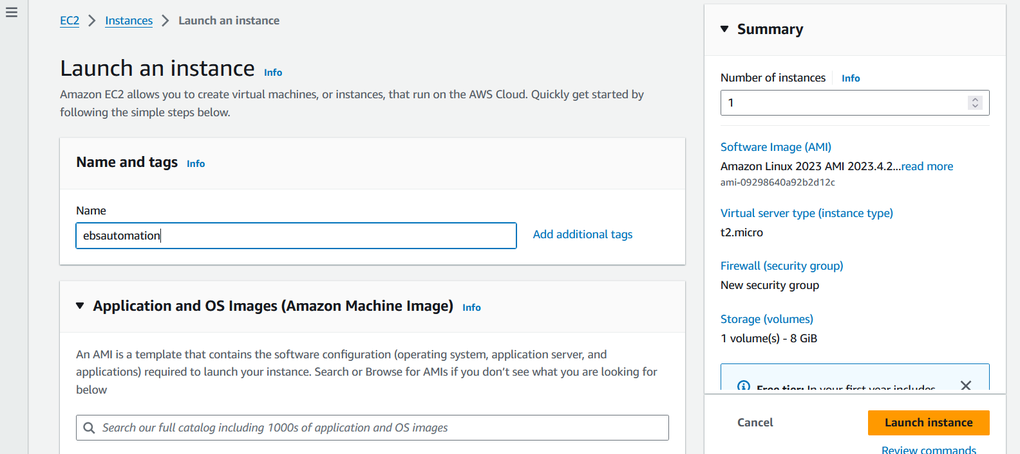 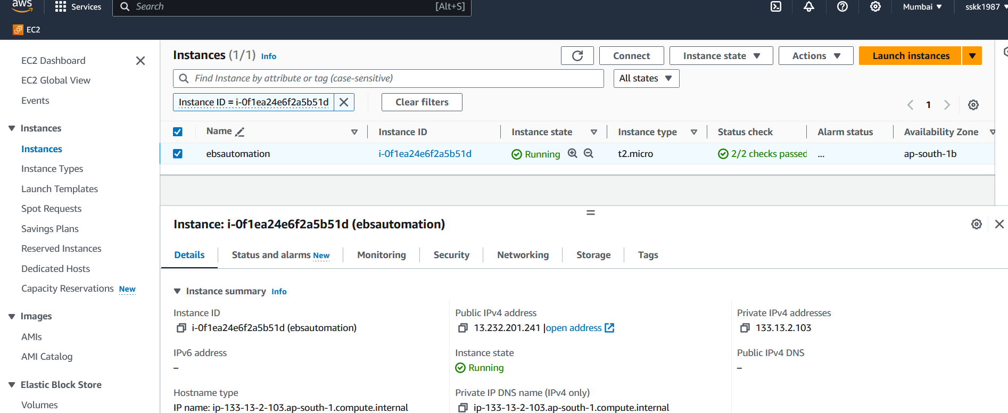

**2. Create a Landing Page:**

* Create a landing page (index.html) on the EC2 instance using a text editor like Nano or Vim.
* Add HTML code for the landing page with two links. For example:

|  |
| --- |
| * html * <!DOCTYPE html> * <html lang="en"> * <head> * <meta charset="UTF-8"> * <meta name="viewport" content="width=device-width, initial-scale=1.0"> * <title>Landing Page</title> * </head> * <body> * <h1>Welcome to the Landing Page</h1> * <ul> * <li><a href="/page1.html">Link 1</a></li> * <li><a href="/page2.html">Link 2</a></li> * </ul> * </body> * </html> |

 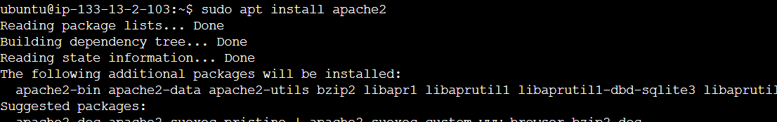 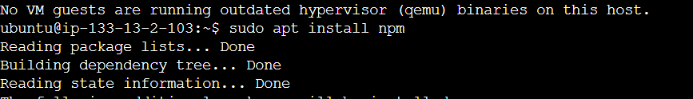 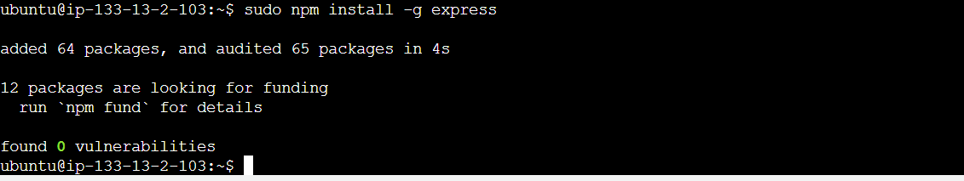 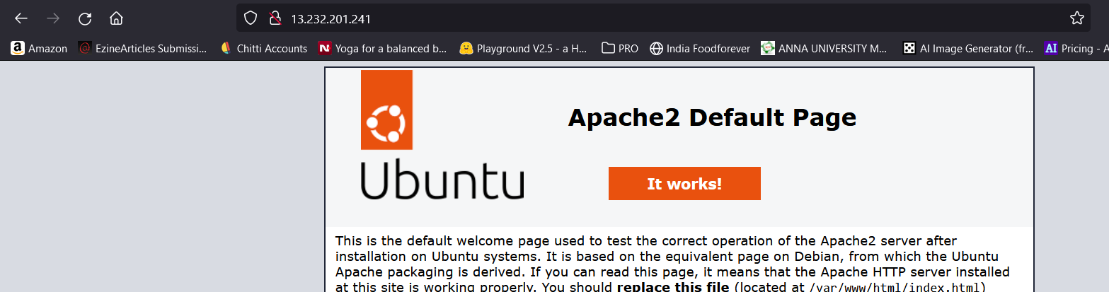

**3. Save the Landing Page on the EC2 Instance:**

* Save the index.html file in the document root directory of the web server on the EC2 instance. For Apache, the document root directory is usually /var/www/html/.

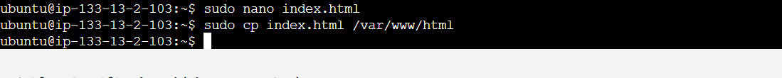

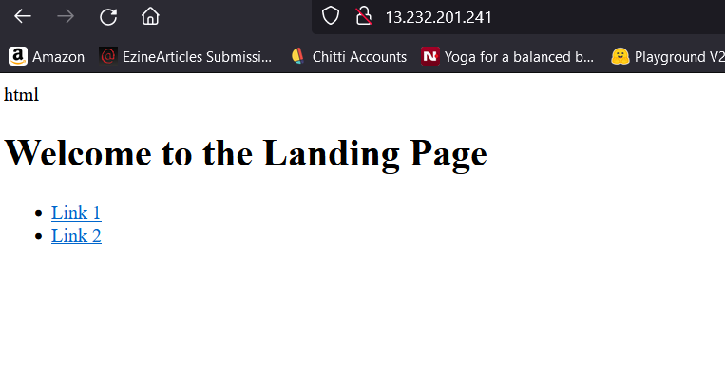

**4. Create Pages for Links**

* Create two HTML pages (page1.html and page2.html) containing the content for the links on the landing page.
* Move these pages to the mounted EBS volume after attaching.
* 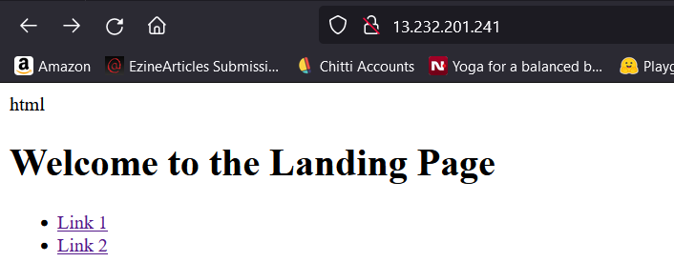 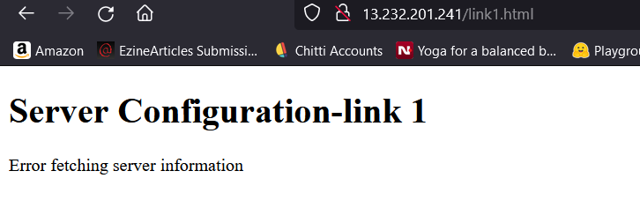
* 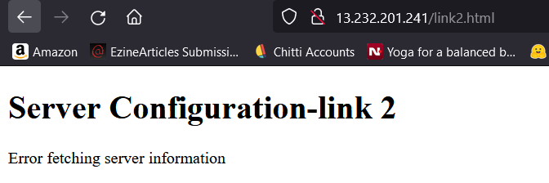

**5. Create and Mount EBS Volume on EC2 Instance:**

* Attach the EBS volume to the EC2 instance and mount it to a directory (e.g., /mnt/ebs).
* Use the following commands:

|  |
| --- |
| bash  sudo mkdir /mnt/ebs  sudo mount /dev/xvdf /mnt/ebs |

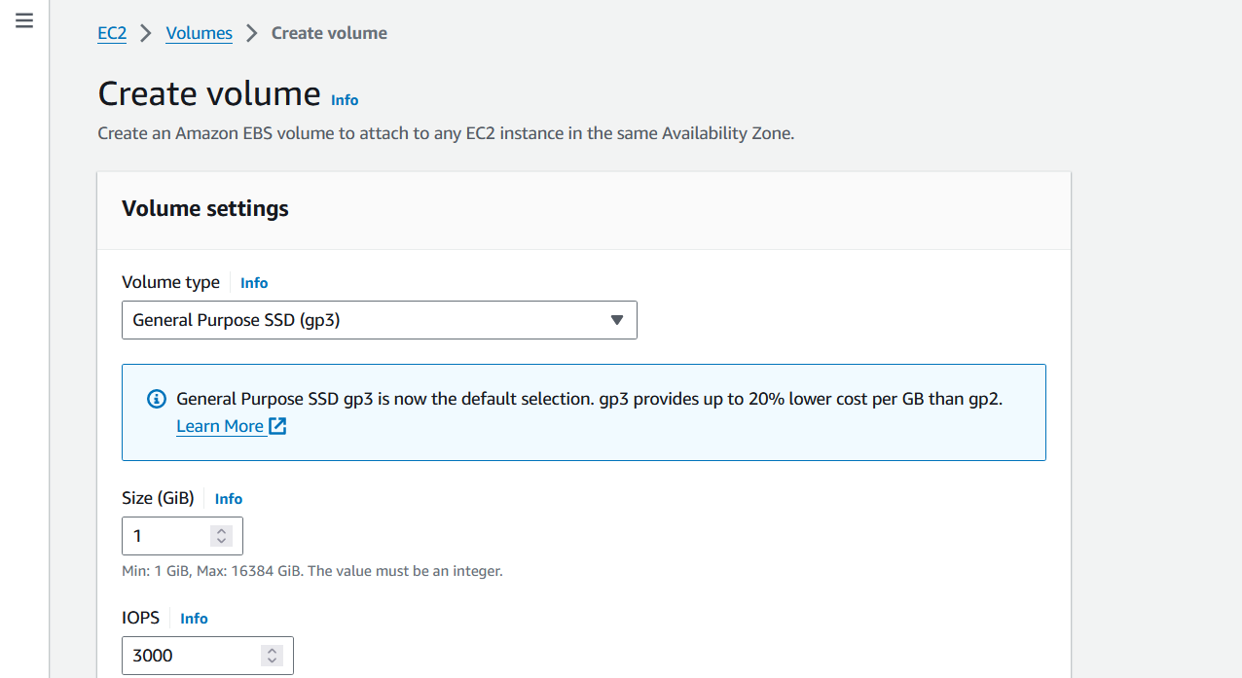

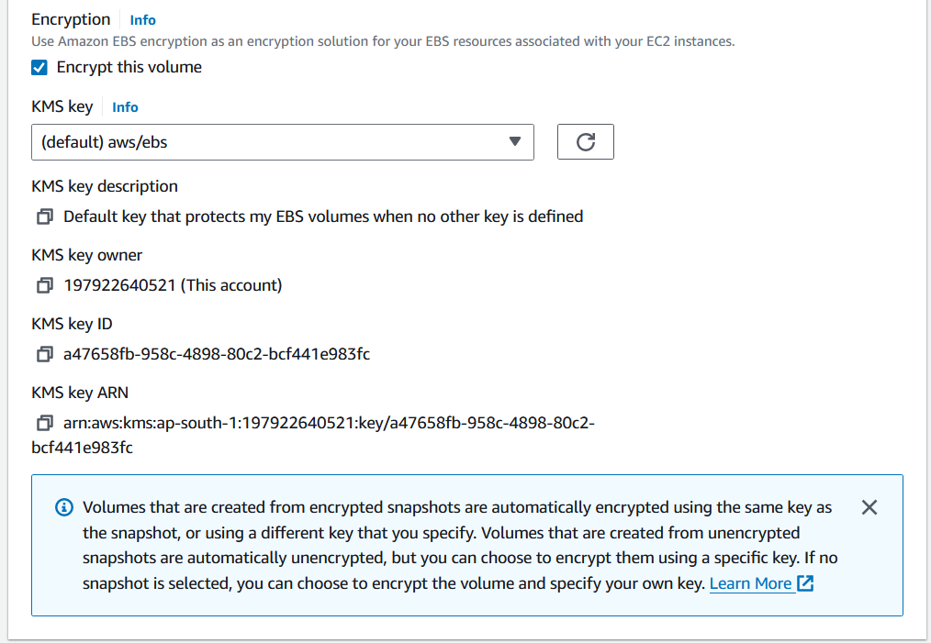

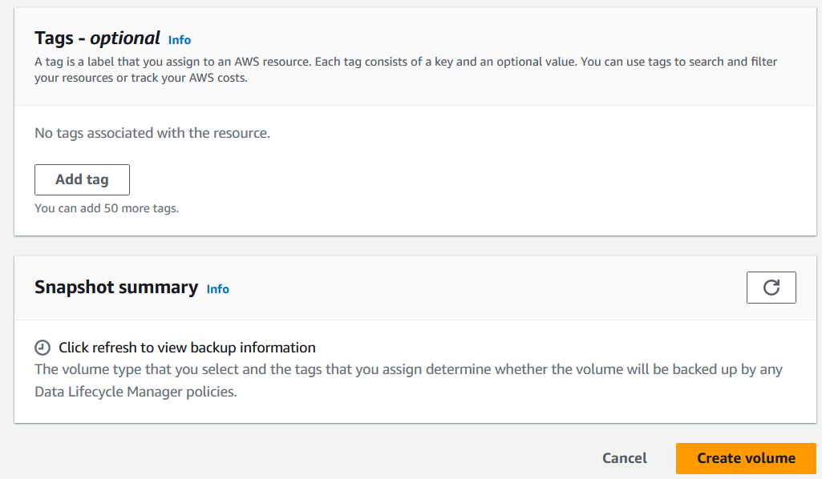

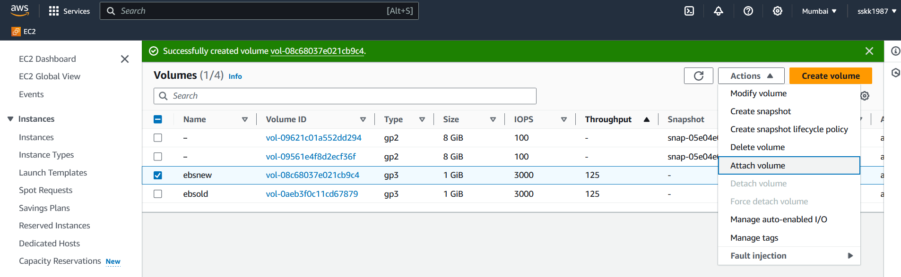

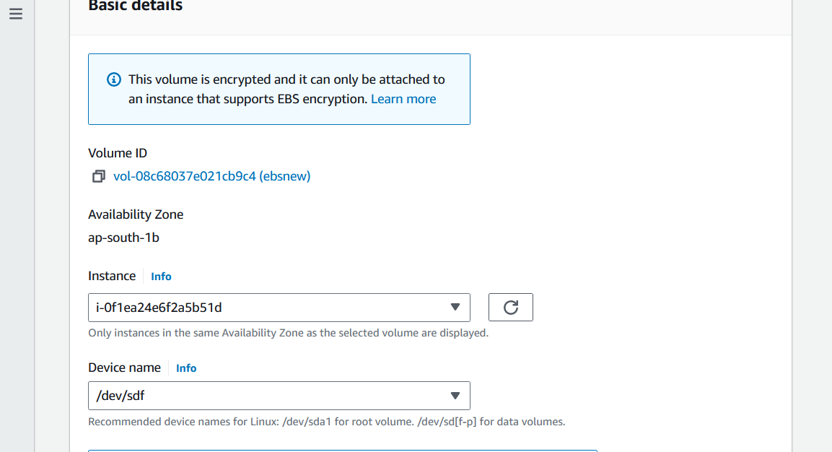

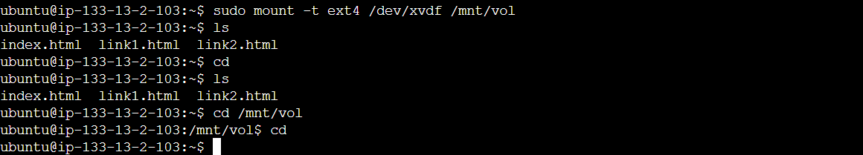

**6. Save HTML Pages on EBS Volume:**

* Copy the page1.html and page2.html files to the mounted directory (/mnt/ebs) on the EC2 instance.

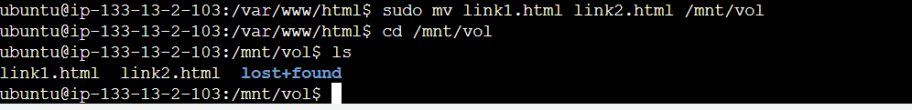

**7. Update Links on Landing Page:**

* Update the href attributes of the links on the landing page (index.html) to point to the respective pages (link1.html and link2.html) stored on the EBS volume.

 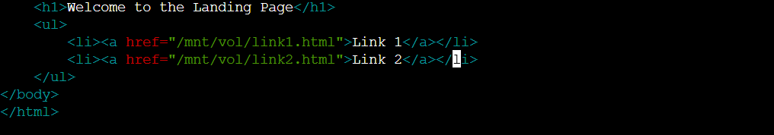

**8. Test the Website:**

* Open a web browser and navigate to the public IP address or DNS name of your EC2 instance.
* Verify that the landing page is displayed with the two links.
* Click on the links to navigate to the respective pages stored on the EBS volume.

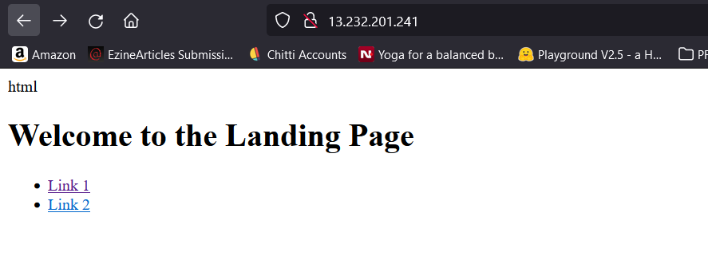

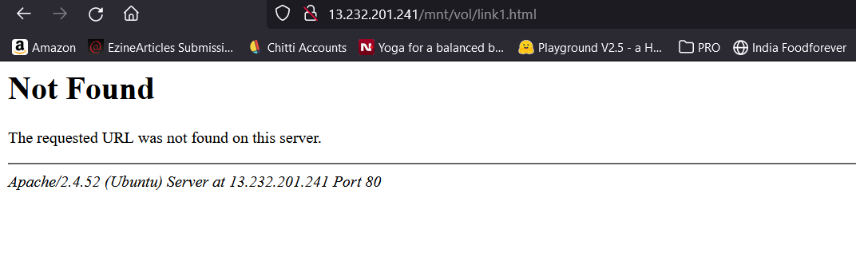

Since link1.html and link2.html is actually located on the EBS volume at /mnt/vol, we need to set up the web server (e.g., Apache) to serve files from this directory

**Update Apache Configuration or create a new config file**

Edit the Apache configuration file. The main configuration file is typically located at /etc/apache2/apache2.conf

Alternatively, we can create a new configuration file under /etc/apache2/sites-available/

We shall go with new configuration file.

**Configure Virtual Host**

Add a new <VirtualHost> block to include the EBS volume directory as a document root.

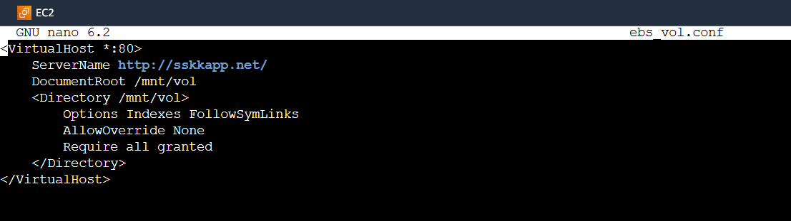

**Enable the Virtual Host:**

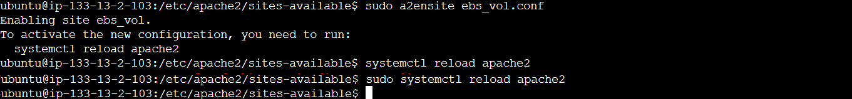

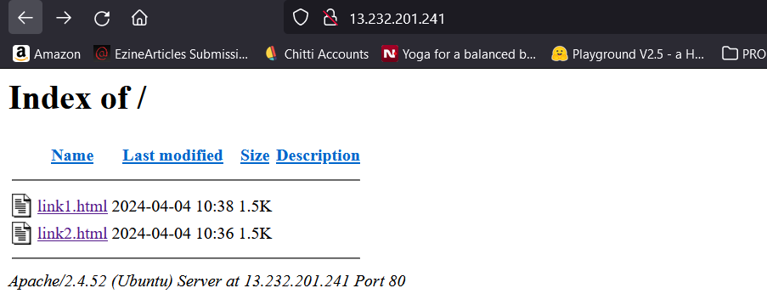

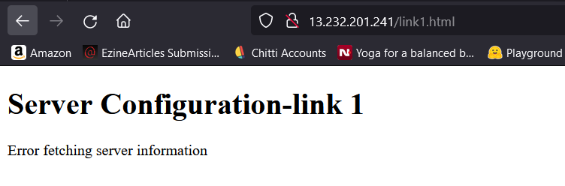

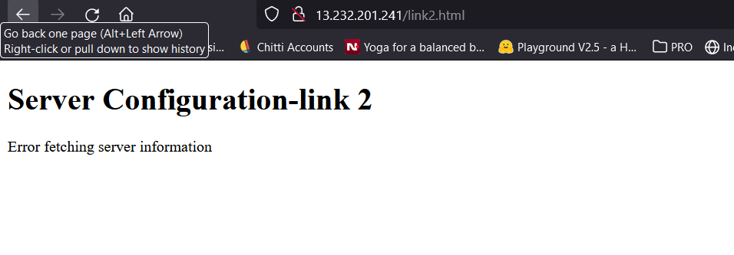

The error message appearing as “Error fetching server information” is due to the fact that the EBS volume does not have any server configuration such as nginx or apache2. The EBS volume just serves as a storage and hence the script shows the error message.

**Part 1: Automated EBS snapshot creation and management solution.**

To set up automated snapshots for the EBS volume /mnt/vol, you can use AWS Lambda functions triggered by a scheduled event in Amazon CloudWatch Events. Here's a general outline of the steps involved:

1. **Create Lambda Function for Snapshot Creation:**
   * Write a Lambda function in Python or Node.js that creates a snapshot of the EBS volume. The function should use the AWS SDK to interact with the EC2 API and create a snapshot of the specified volume (/mnt/vol).

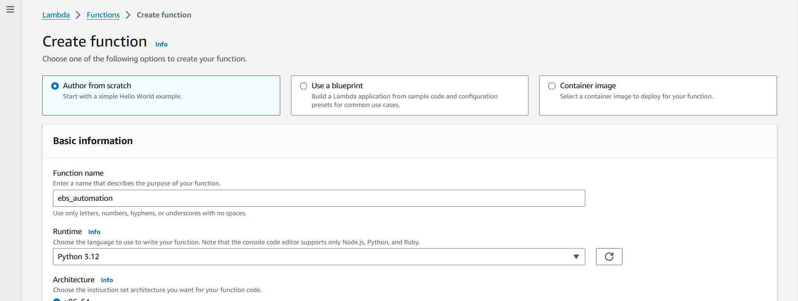 

|  |
| --- |
| import boto3  def lambda_handler(event, context):  # Specify the region and volume ID  region = 'your-region'  volume_id = 'your-volume-id'  # Create an EC2 client  ec2_client = boto3.client('ec2', region_name=region)  # Create a snapshot of the volume  response = ec2_client.create_snapshot(  VolumeId=volume_id,  Description='Automated snapshot created by Lambda function'  )  # Log the snapshot ID  snapshot_id = response['SnapshotId']  print(f'Snapshot created: {snapshot_id}')  return {  'statusCode': 200,  'body': f'Snapshot created: {snapshot_id}'  } |

* Ensure that the Lambda function has the necessary IAM permissions to create snapshots. You can create a custom IAM policy with the required permissions and attach it to the Lambda execution role.

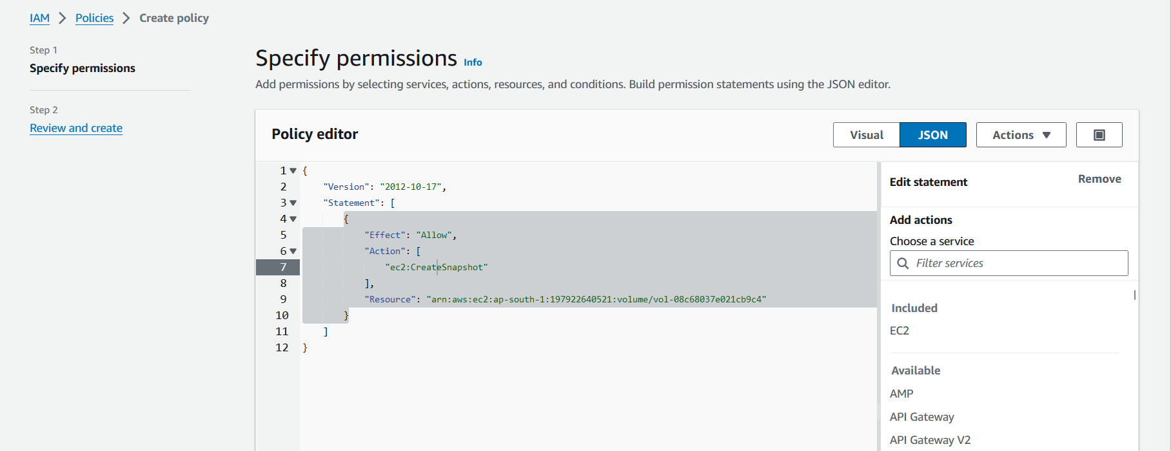

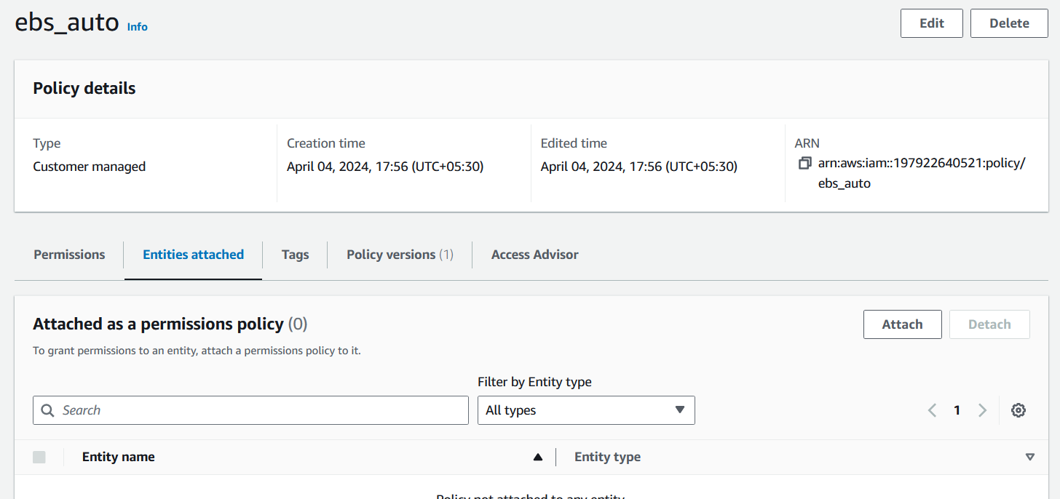

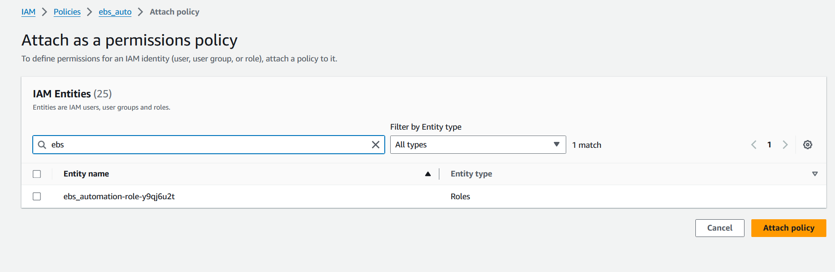

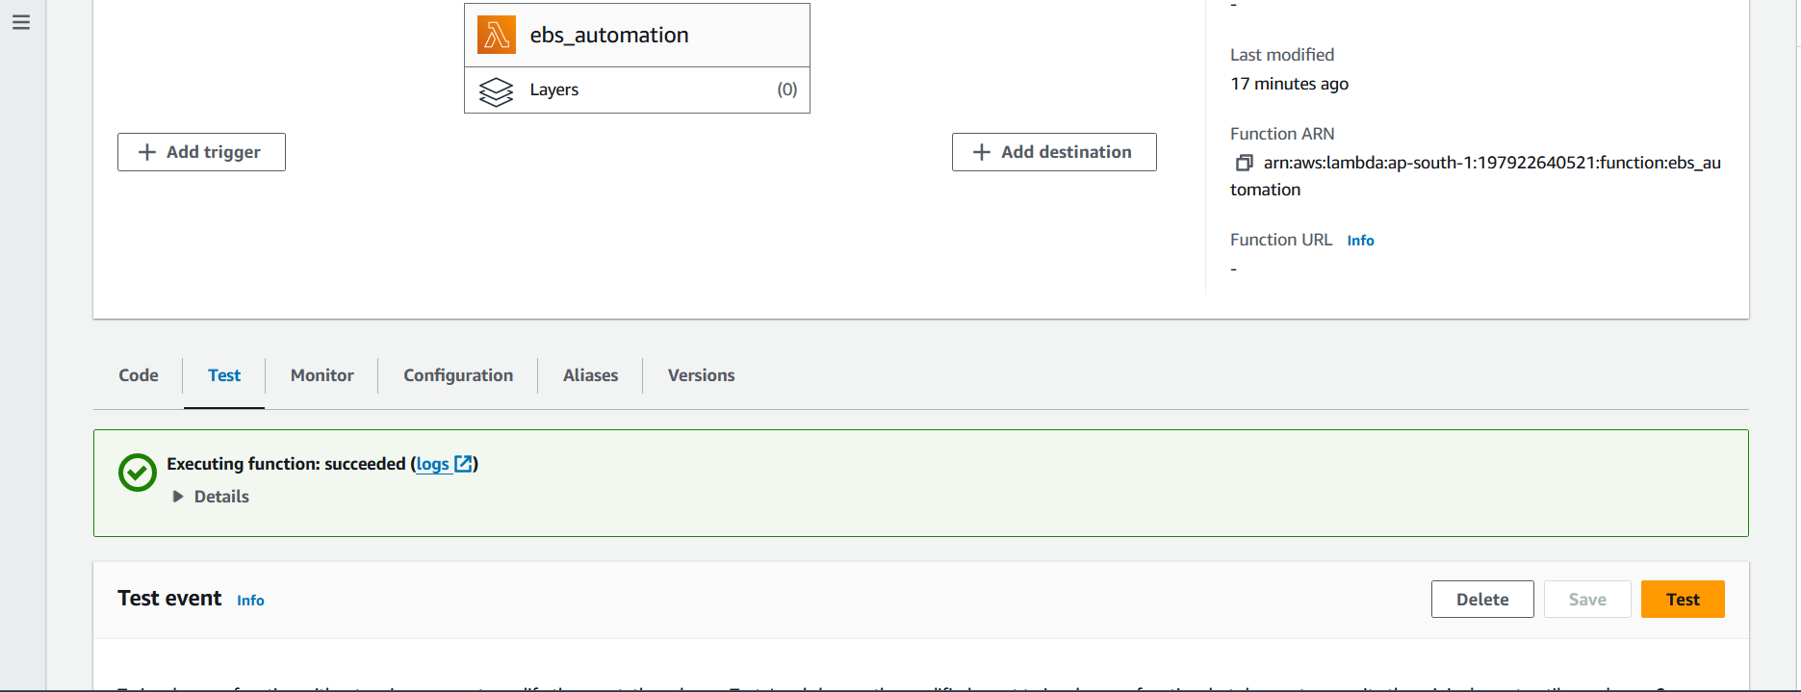

1. **Set Up Amazon EventBridgeRule:**
   * Create a new rule in Amazon EventBridge with a schedule expression to trigger the Lambda function at the desired interval (e.g., every hour).
   * Configure the rule to trigger the Lambda function.

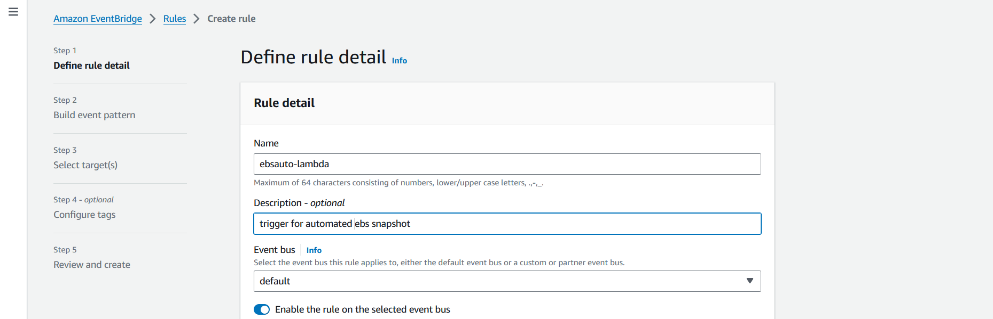

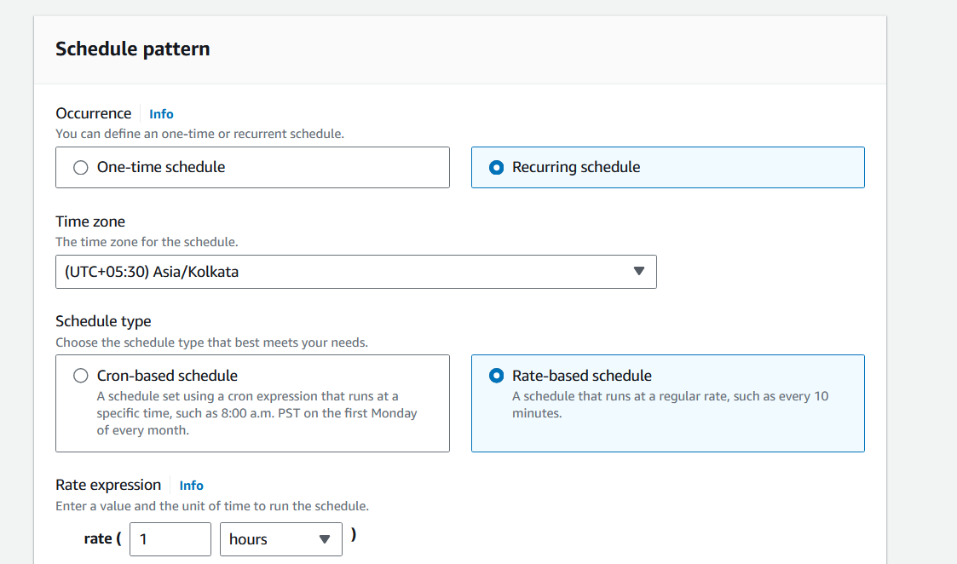

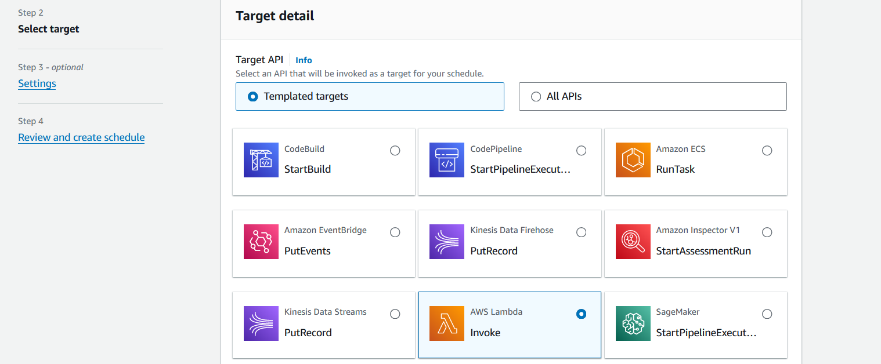 

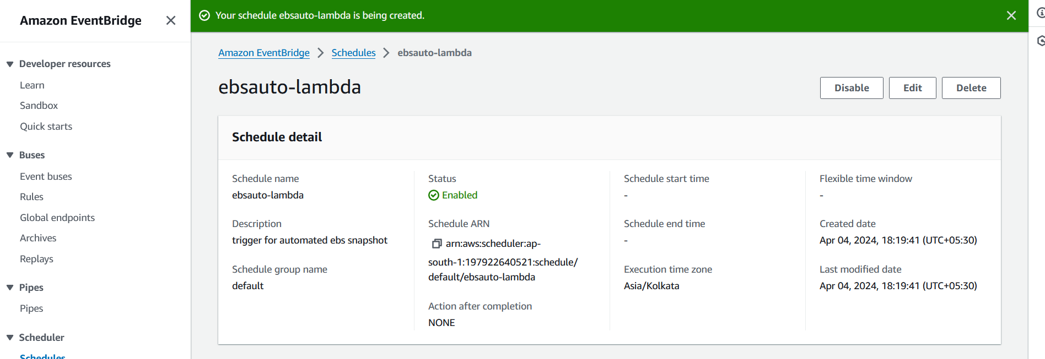

1. **Test the Automation:**
   * Test the Lambda function and CloudWatch Events rule to ensure that snapshots are created automatically at the specified interval.
   * Monitor the CloudWatch Logs for any errors or issues encountered during snapshot creation.

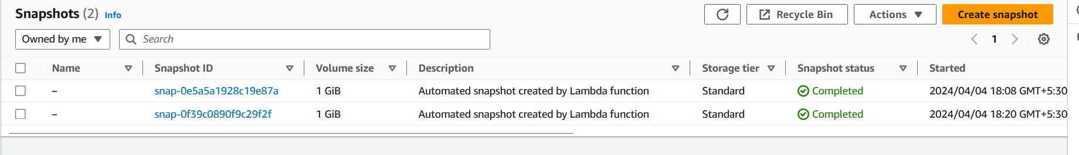

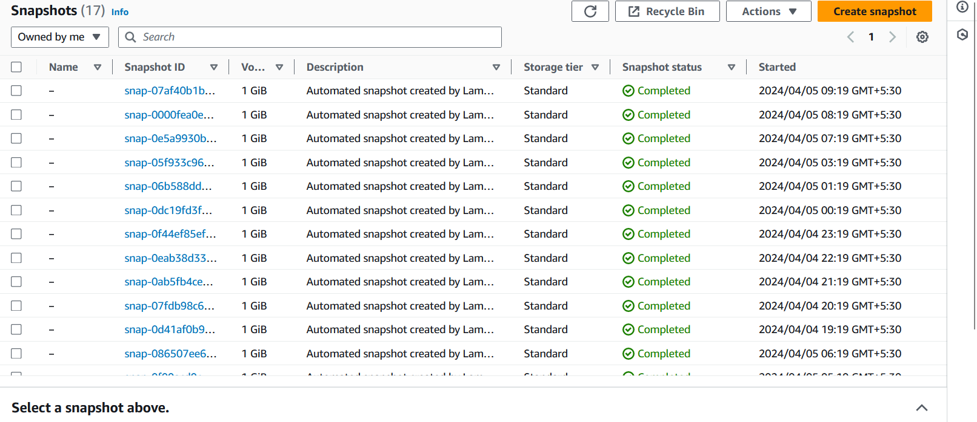

**Key Features and Functionalities:**

1. **Automated Snapshot Creation:** The Lambda function automatically creates a snapshot of the specified EBS volume.
2. **Tagging:** Tags the created snapshot with a 'Name' tag for easy identification.
3. **Retention Policy:** Deletes old snapshots based on the specified retention period.
4. **Customizable:** Parameters such as VolumeId and RetentionDays can be passed to the function via the event object, making it customizable for different use cases.
5. **Serverless:** The function runs on the AWS Lambda service, eliminating the need to manage server infrastructure.

**Setup Instructions:**

1. Create a new AWS Lambda function in your AWS Management Console.
2. Choose Python 3.x as the runtime.
3. Copy and paste the provided code into the Lambda function editor.
4. Configure the function with appropriate permissions to interact with EC2 resources. Ensure the Lambda execution role has permissions to create and delete snapshots.
5. Set up a CloudWatch Events rule to trigger the Lambda function at your desired schedule (e.g., daily).

**Part 2: Testing and Verification**

**Test Cases and Scenarios Covered:**

The following test cases and scenarios were covered during testing:

1. **Snapshot Creation Test:**
   * Verify that snapshots are created successfully for the specified EBS volume.
   * Check that the correct description and tags are applied to the snapshots.



1. **Retention Policy Test:**
   * Test the retention policy by verifying that snapshots are retained according to the defined schedule (e.g., daily, weekly, monthly).

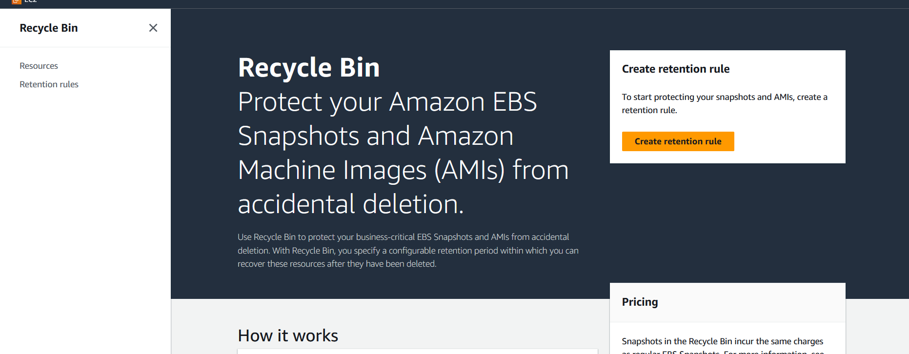

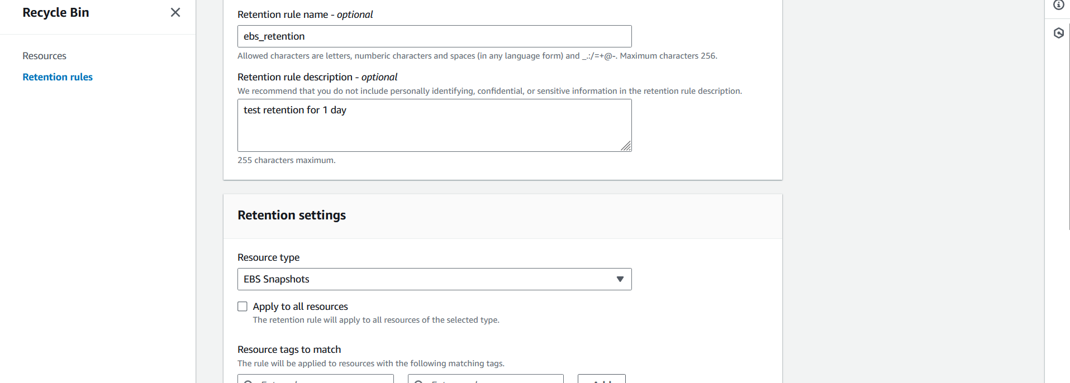

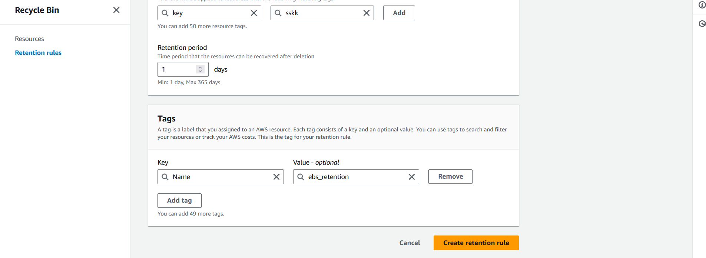

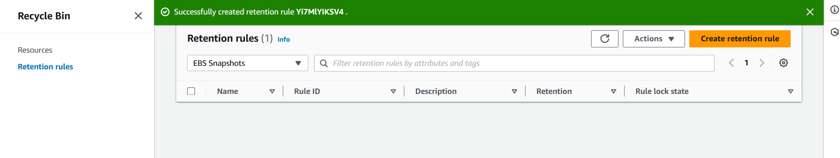

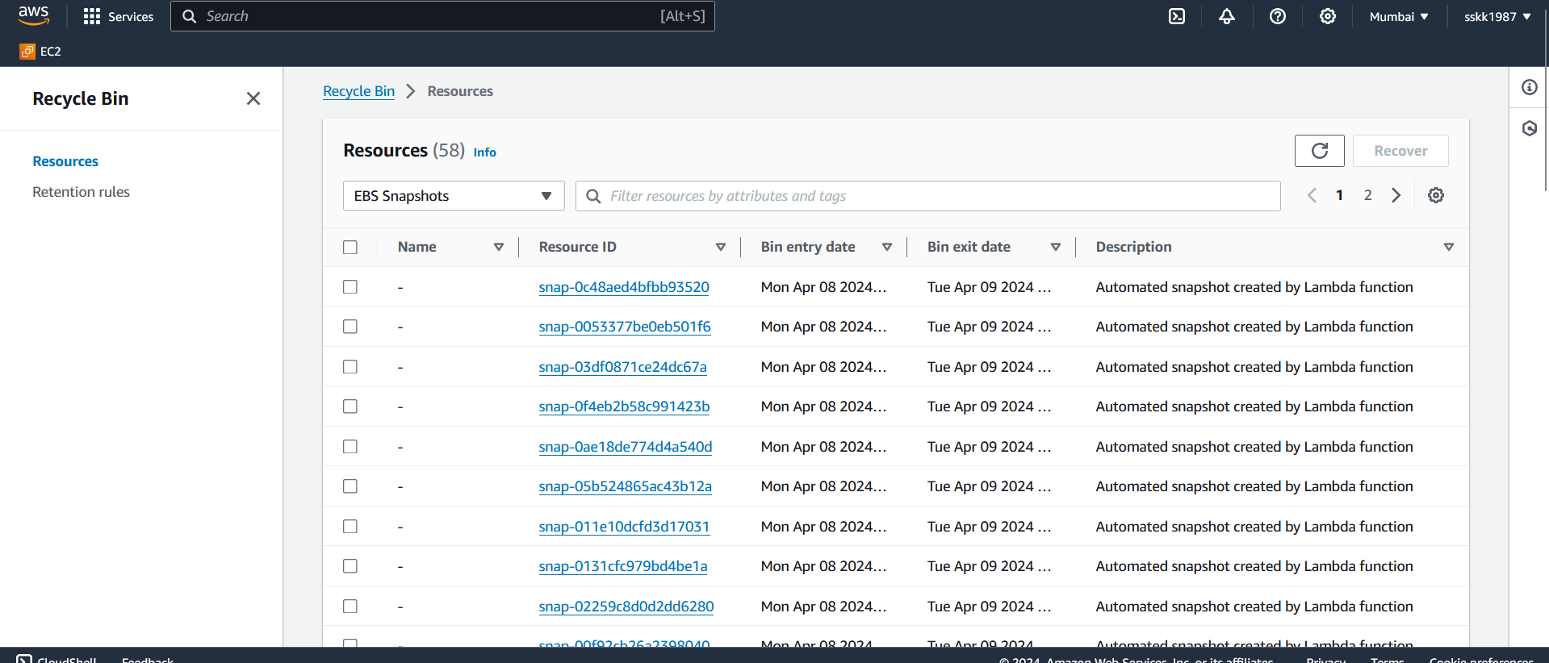

1. **Error Handling Test (Missing or detached volume test)**

* Detach the volume and check the website

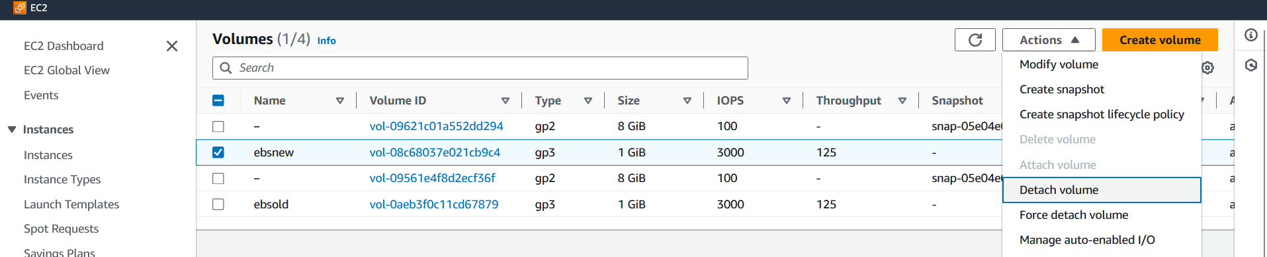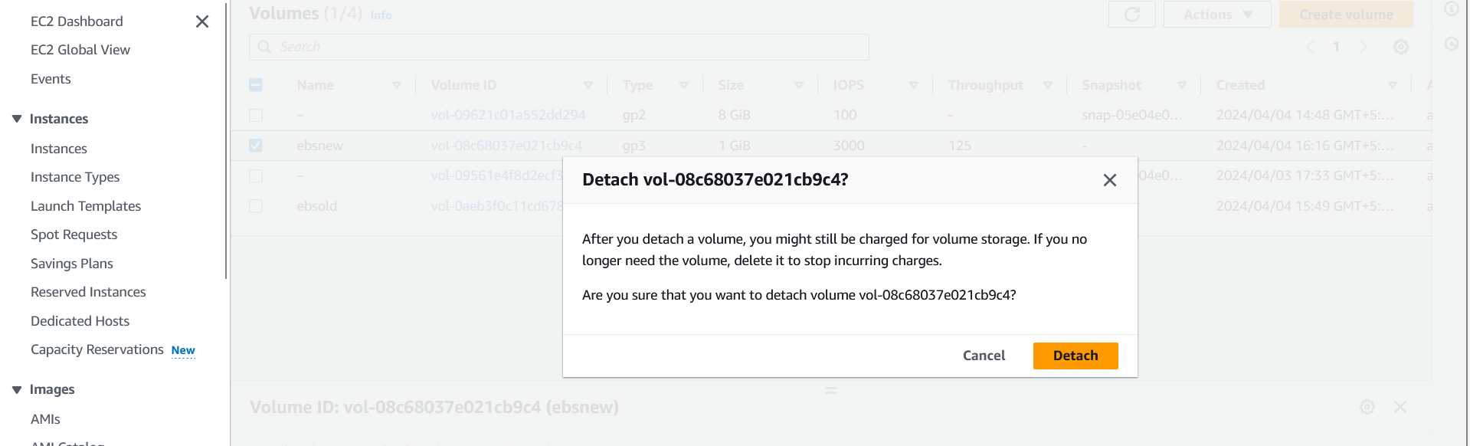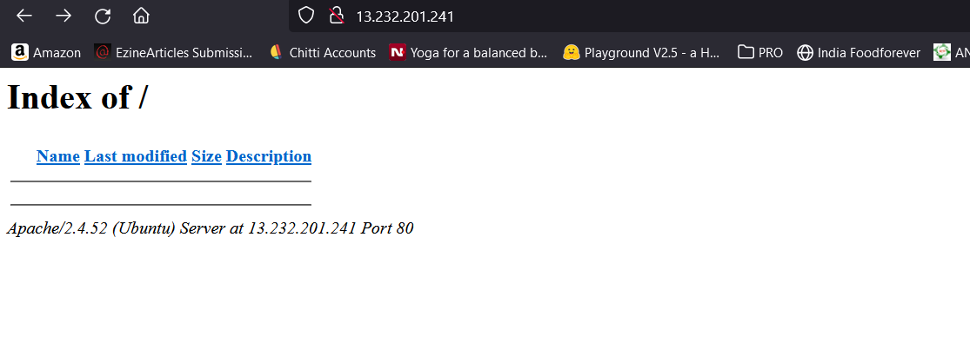

* The site doesn’t work. So to make the site operate smooth, we need to re-attach the ebs volume.

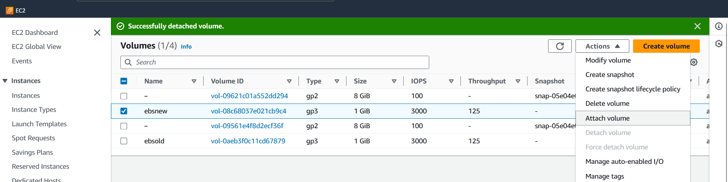

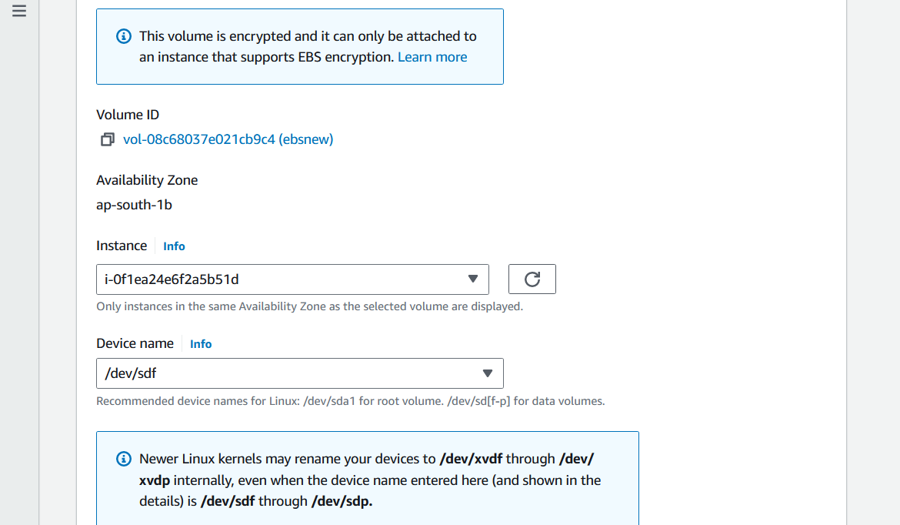

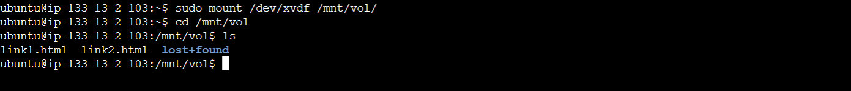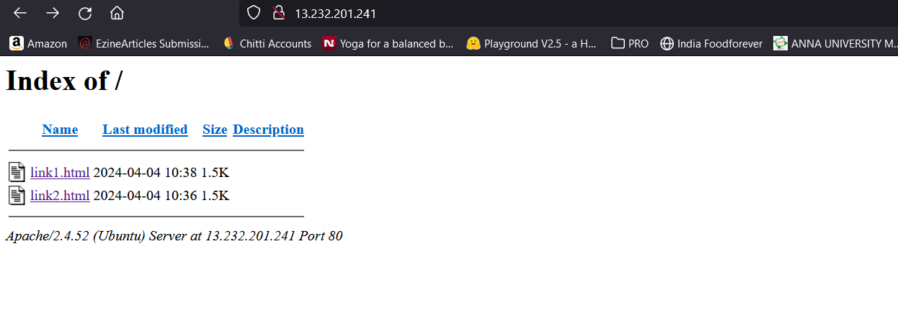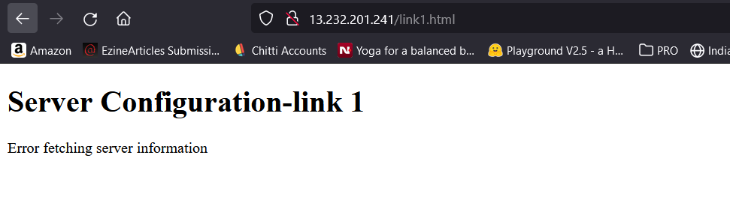

**Part 3: Disaster Recovery**

**1. Overview:**

The disaster recovery plan aims to ensure the timely and effective recovery of data and systems in the event of a disaster or disruption. The primary objective is to minimize downtime and data loss, thereby maintaining business continuity and preserving critical operations. The scope of the plan encompasses all systems and data stored on Amazon EBS volumes within the AWS environment.

**2. Procedures for Restoring Data from EBS Snapshots:**

 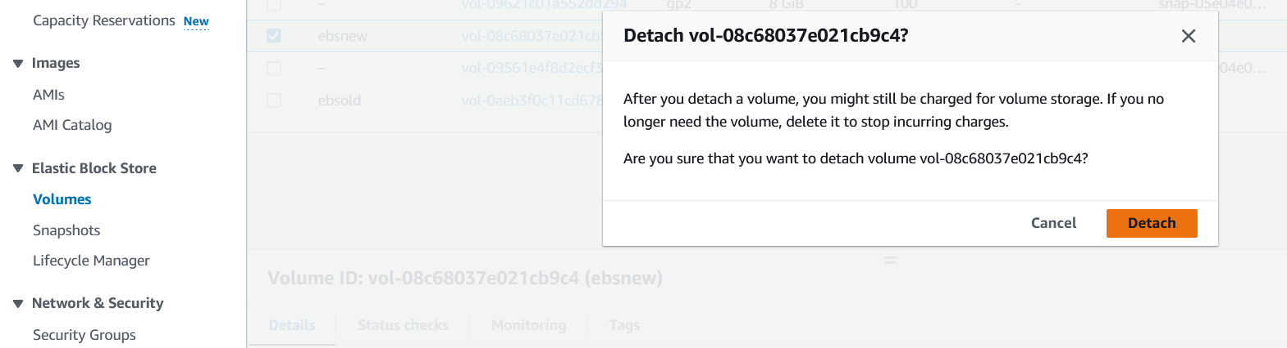

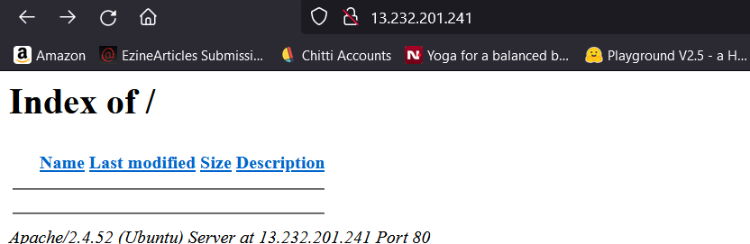

In the event of a disaster or data loss scenario, the following procedures will be followed to restore data from EBS snapshots:

1. **Assessment and Notification:**
   * The incident response team will assess the nature and extent of the disaster.
   * The designated personnel will notify key stakeholders and initiate the disaster recovery process.
2. **Snapshot Selection:**
   * Identify the most recent and relevant EBS snapshots for each affected volume.
   * Consider the snapshot retention policy to ensure the availability of appropriate recovery points.

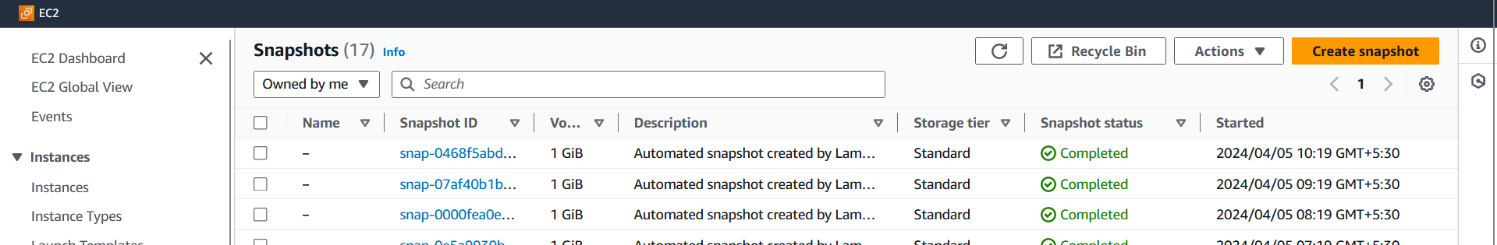

1. **Volume Restoration:**
   * Create new EBS volumes based on the selected snapshots using the AWS Management Console or CLI.
   * Attach the restored volumes to the appropriate EC2 instances.

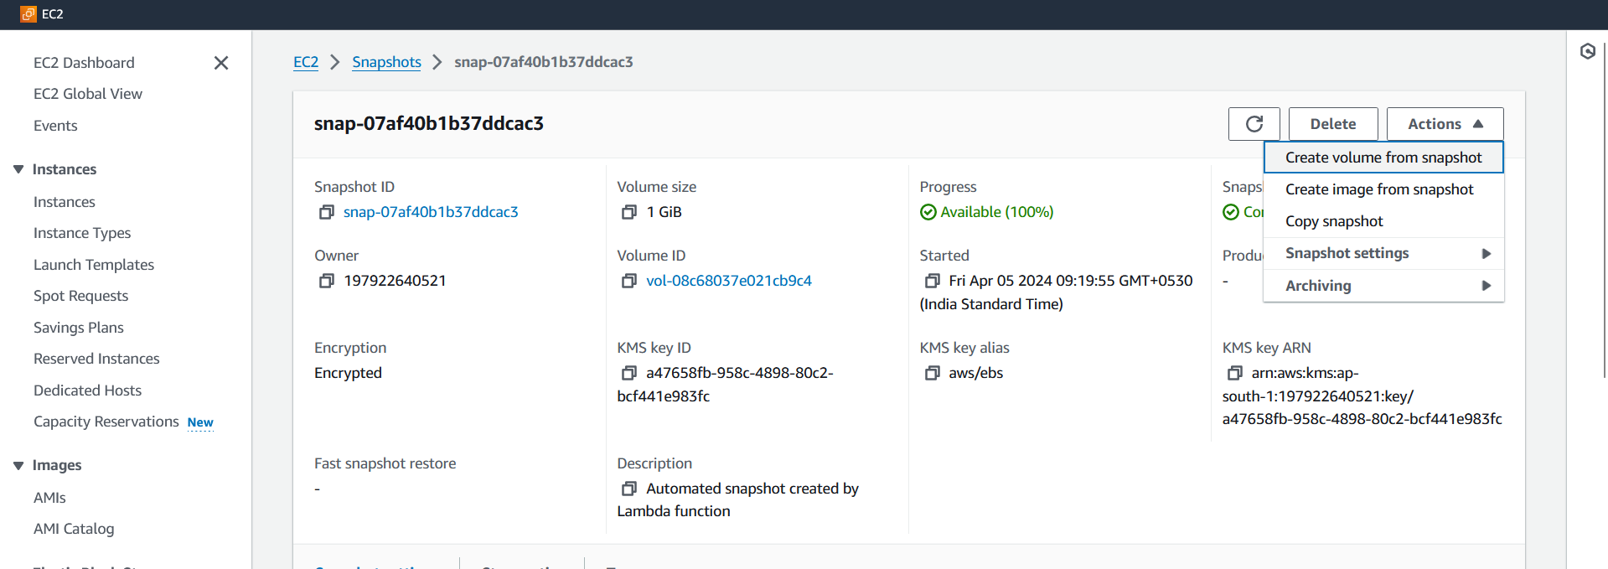

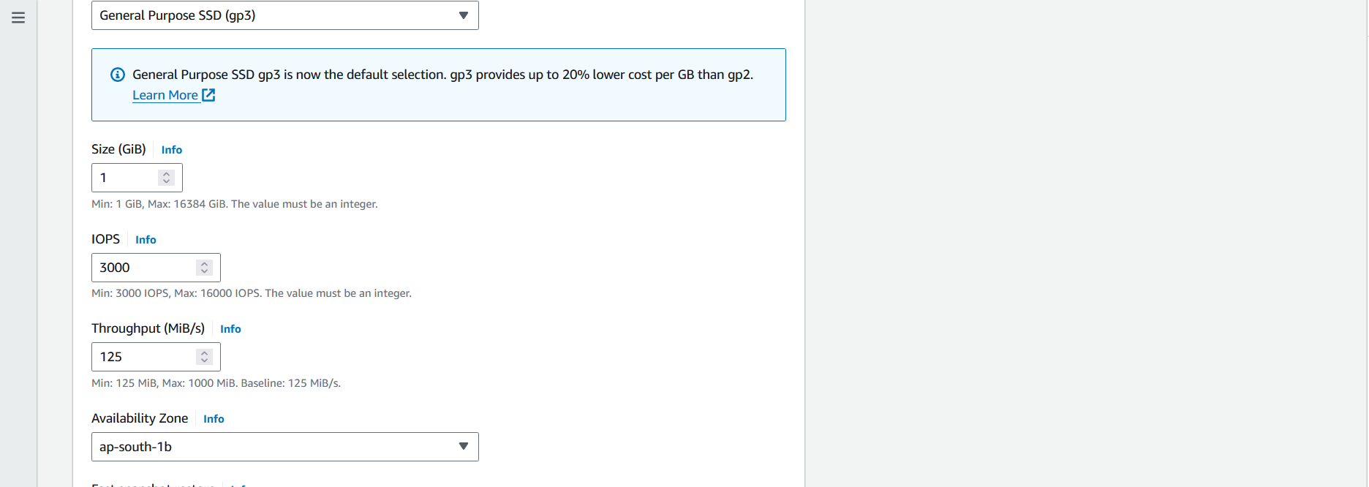

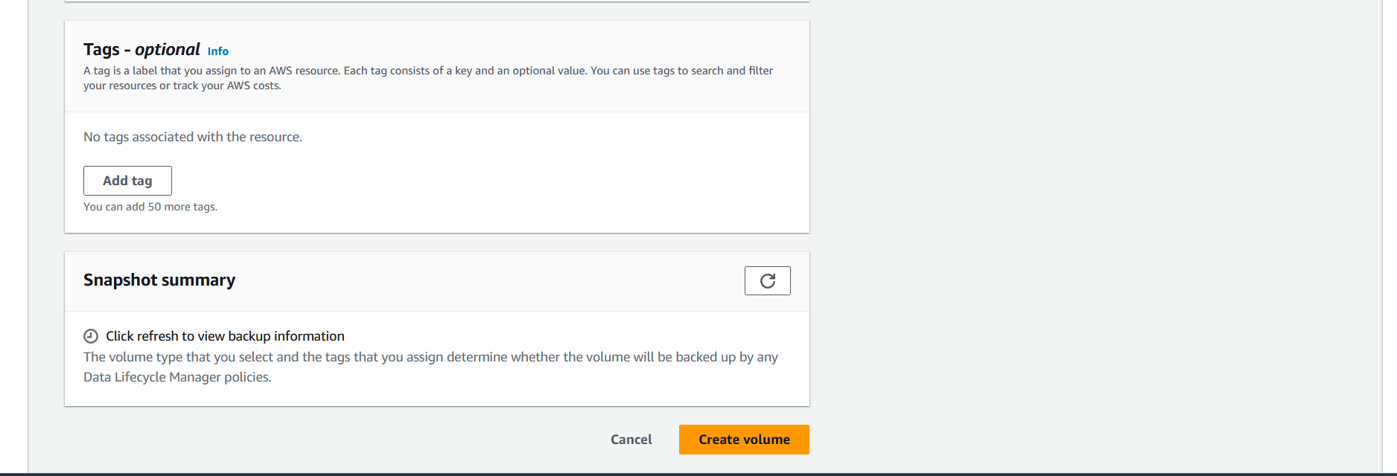 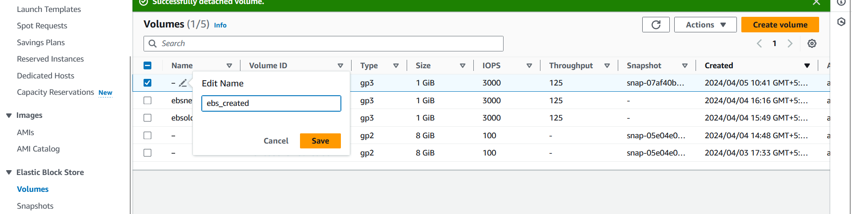 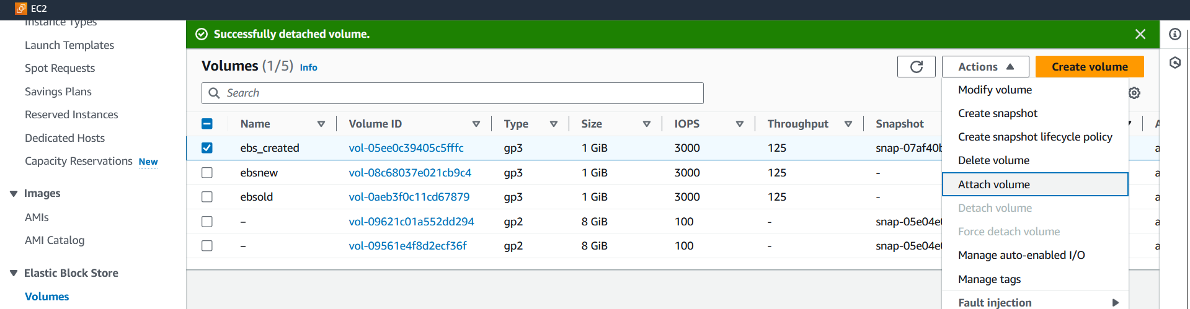 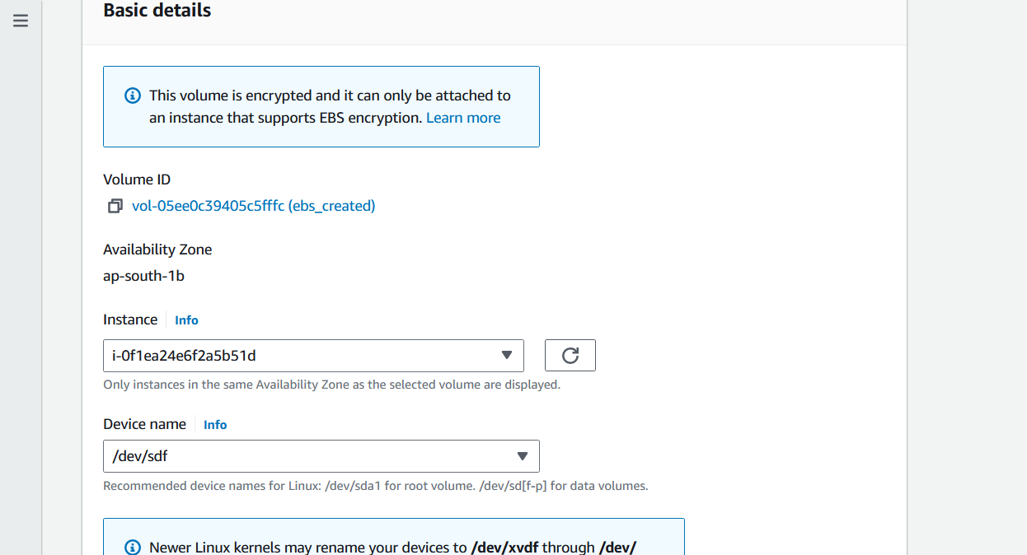 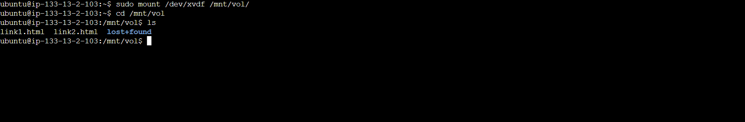

1. **Data Verification and Service Restoration:**
   * Validate the integrity and completeness of the restored data.
   * Perform necessary checks to ensure that critical systems and applications are functioning correctly.

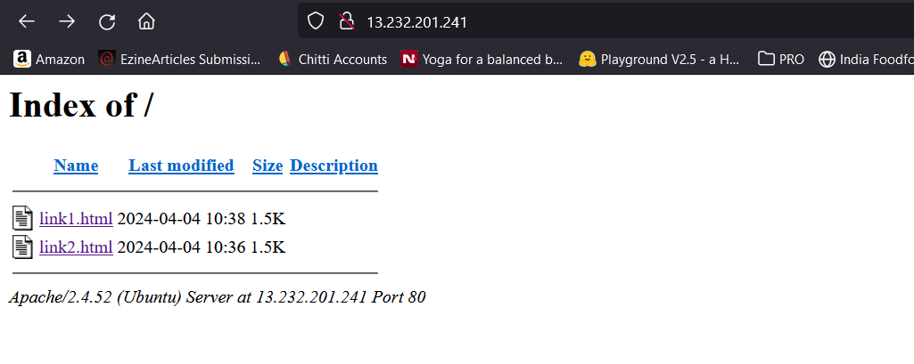 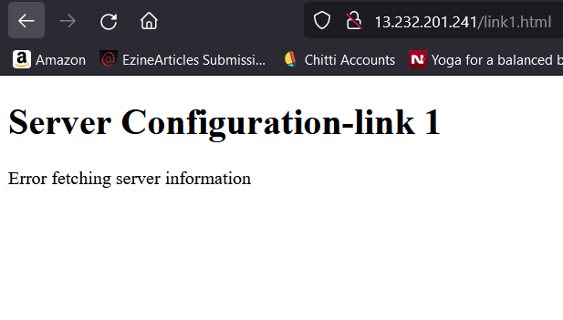 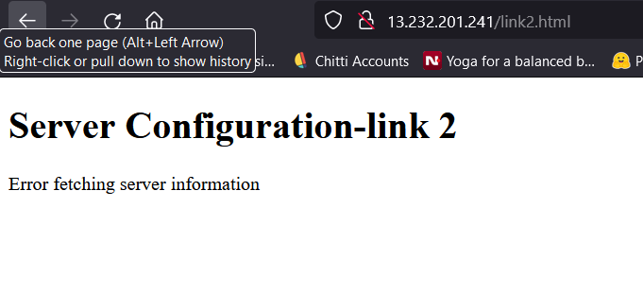

**Part 4: Lambda Function for Snapshot Cleanup**

After completing the project, don't forget to delete the CloudFormation stack to avoid incurring unnecessary charges

|  |
| --- |
| import boto3  def lambda_handler(event, context):  # Specify the region where your snapshots reside  region = 'your-region'    # Initialize the EC2 client  ec2_client = boto3.client('ec2', region_name=region)    # List all snapshots in the region  snapshots = ec2_client.describe_snapshots(OwnerIds=['self'])['Snapshots']    # Iterate over snapshots and delete snapshots older than retention period  for snapshot in snapshots:  snapshot_id = snapshot['SnapshotId']  snapshot_time = snapshot['StartTime']  retention_period = 1 # specify retention period in days    # Calculate the deletion timestamp based on the retention period  if (snapshot_time.date() - datetime.today().date()).days >= retention_period:  # Delete snapshot  ec2_client.delete_snapshot(SnapshotId=snapshot_id)  print(f"Snapshot {snapshot_id} deleted") |

Create a function using the format above by replacing the particulars and deploy the function to perform a cleanup of stored snapshots.

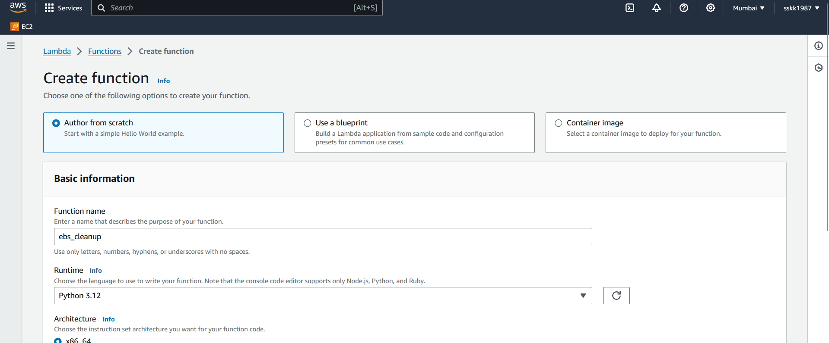

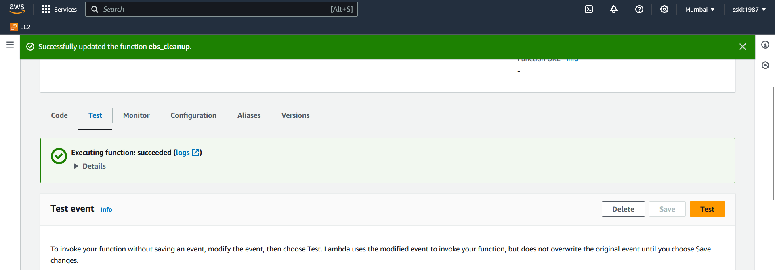

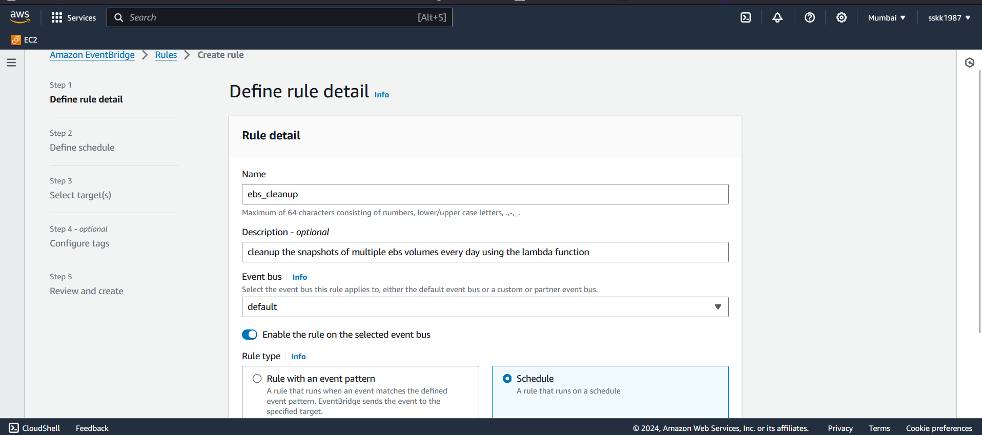

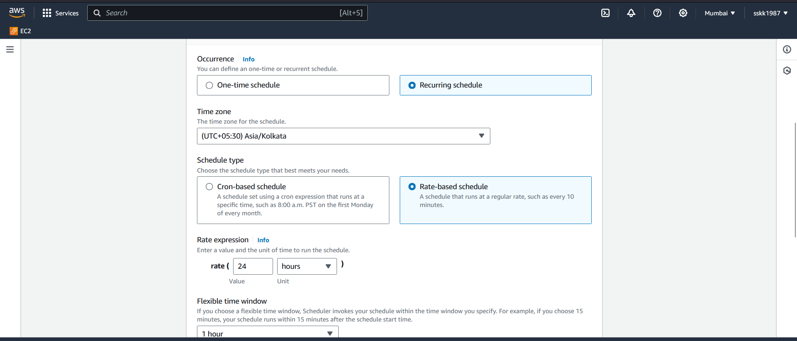

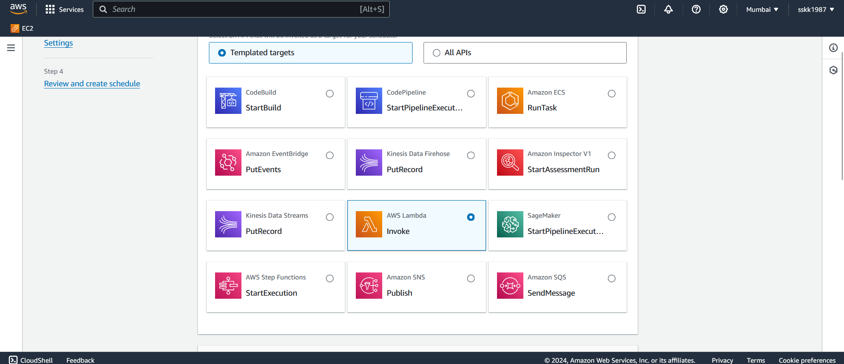 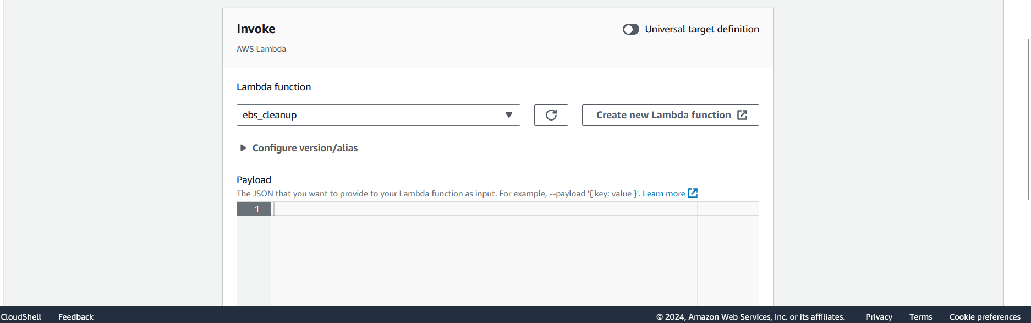 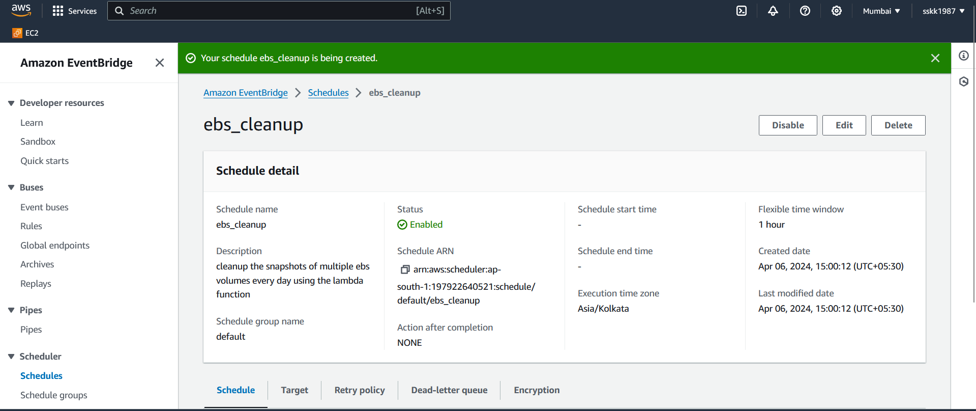

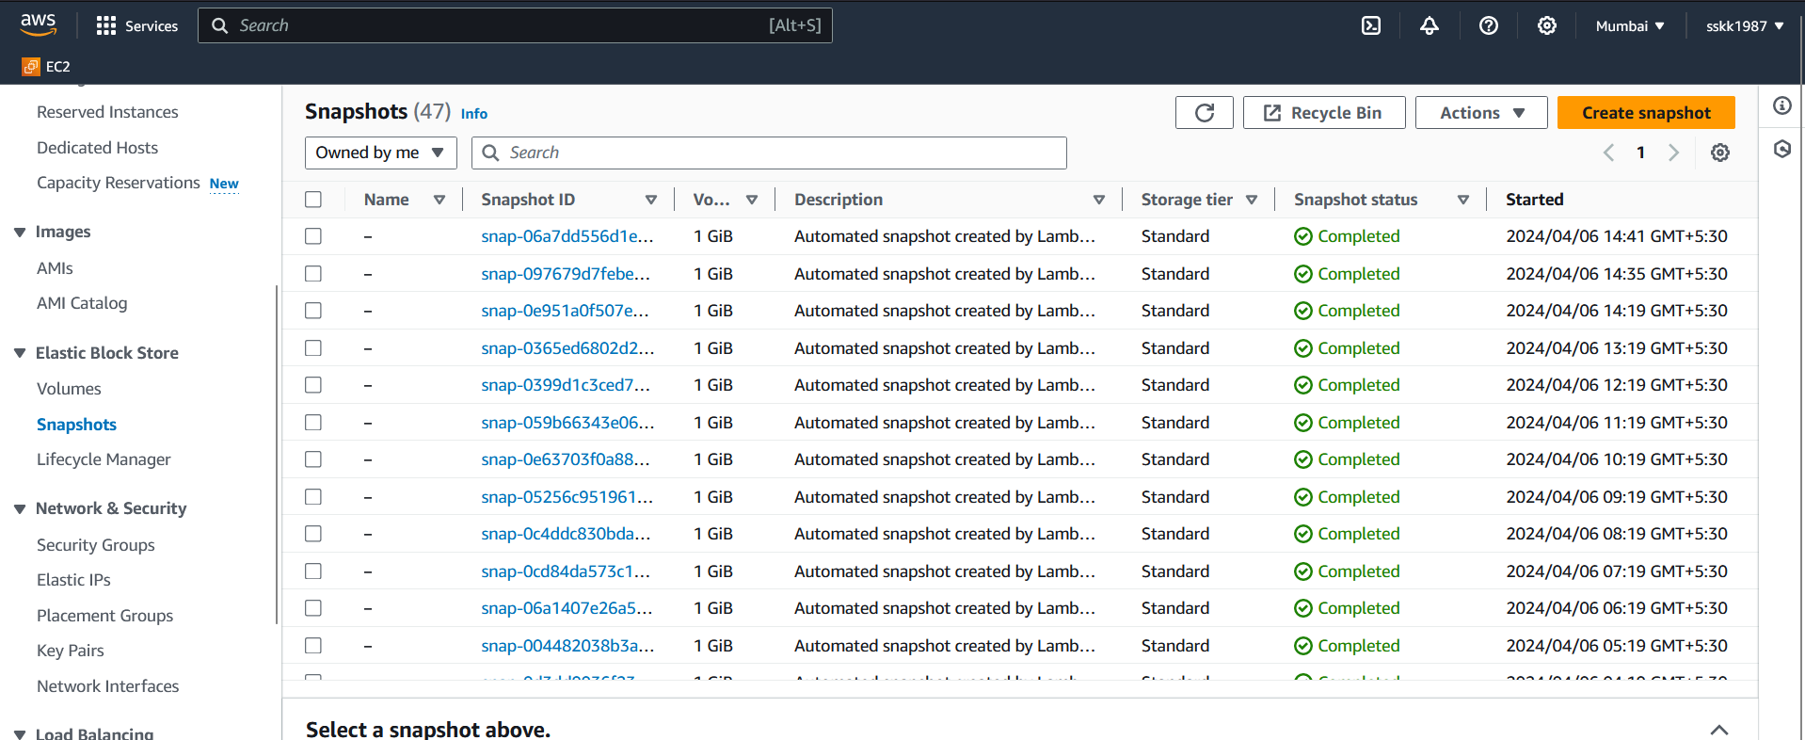

Once the function is created and deployed, the cleanup process starts as defined by the trigger.



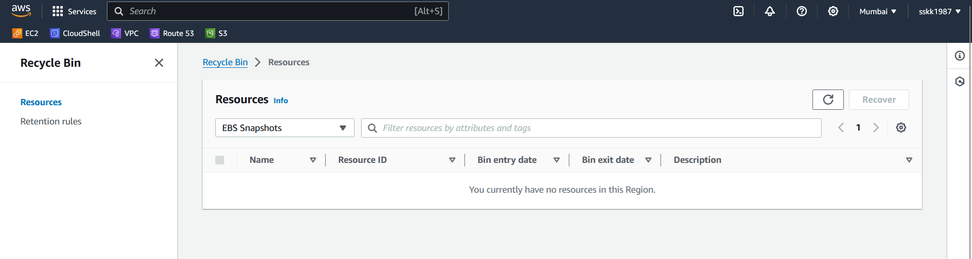

**Part 5: Enable cross region access and cross account access**

To enable cross-region and cross-account access for an Amazon Elastic Block Store (EBS) volume in the ap-south-1 region (Asia Pacific (Mumbai)), you'll need to follow these general steps. But remember the fact that, we can only share snapshots that are encrypted with a customer managed key. Create a fresh volume and follow the mounting principles and verification as before,

1. **Create a Snapshot of the EBS Volume**:
   * Before enabling cross-region and cross-account access, you typically create a snapshot of the EBS volume. Snapshots are used to create volumes in other regions or share with other AWS accounts.
2. **Share the Snapshot with Another AWS Account (Cross-Account Access)**:
   * Go to the Amazon EC2 console.
   * Navigate to the "Snapshots" section.
   * Select the snapshot we want to share., choose the most recent one for updated version of resources

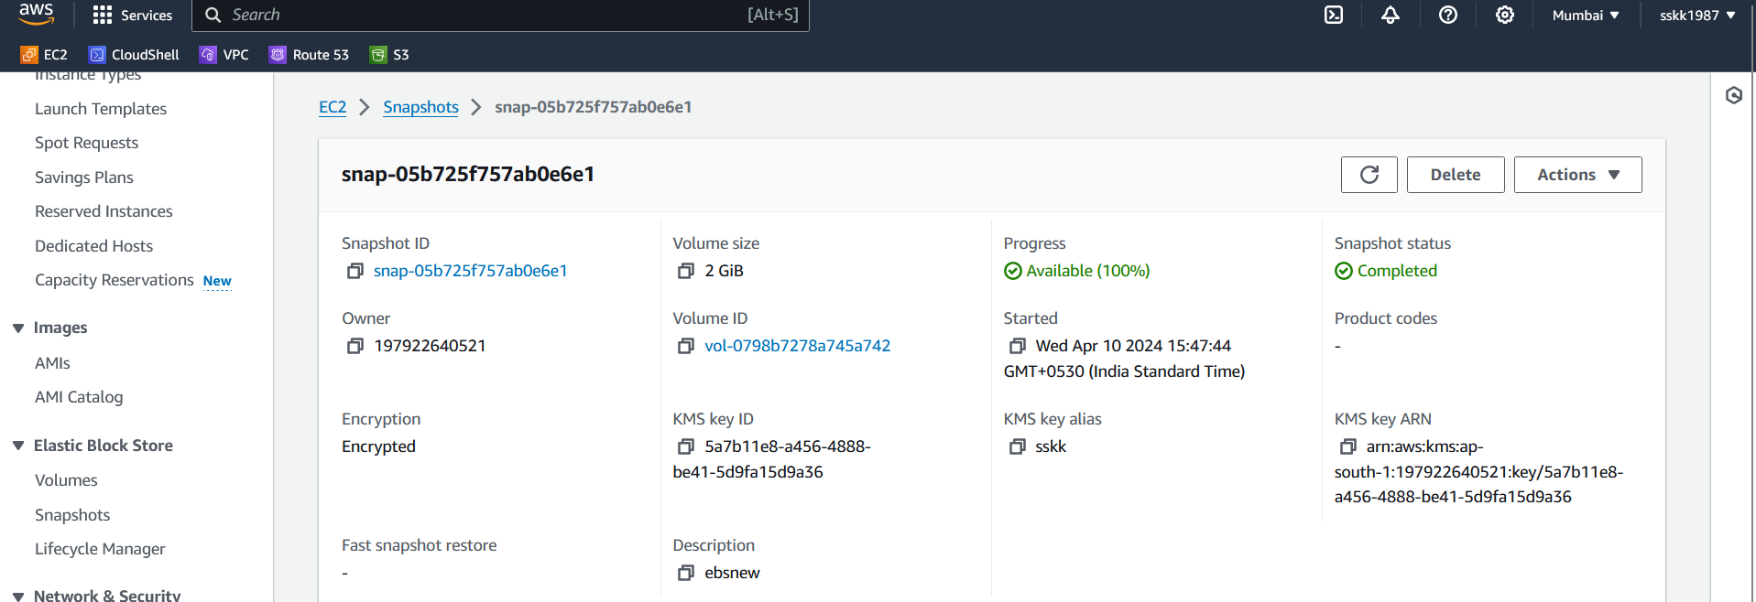.

* + Choose "Add account ID".

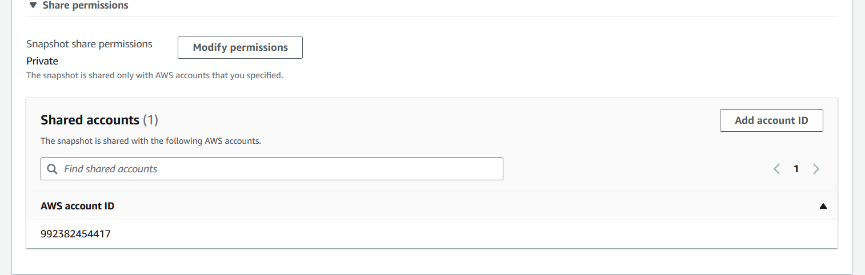

* + Enter the AWS Account ID of the account you want to share the snapshot with.

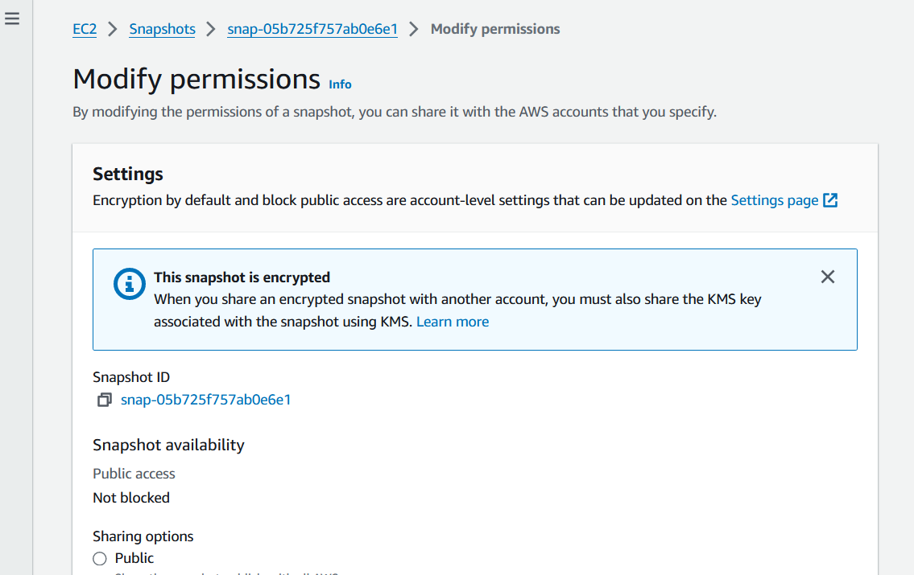

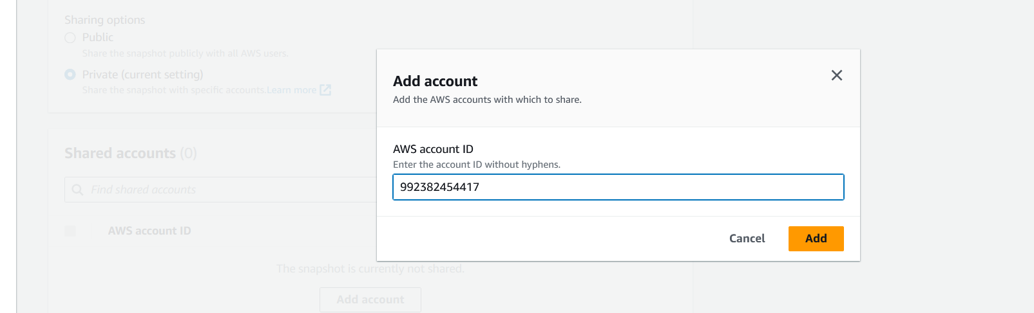 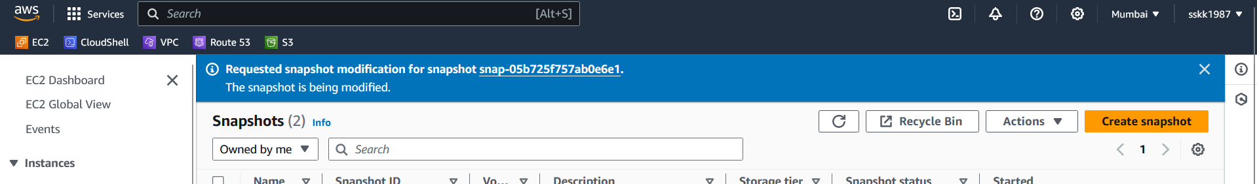

* + Click "Add permission".

Currently, there is no direct CloudFormation resource available for sharing EBS snapshots with another AWS account. We can use custom resources and AWS Lambda to accomplish this task indirectly within a CloudFormation template

1. **Create a Volume from the Copied Snapshot in the Other account**:
   * After the snapshot is copied to the other account, navigate to the EC2 console.
   * In the "Snapshots" section, locate the copied snapshot.

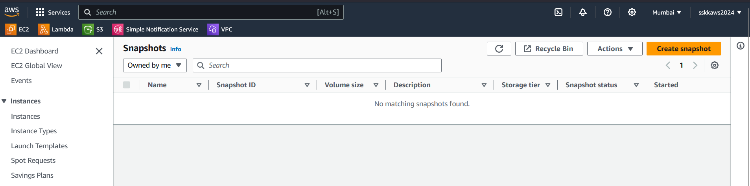

The snapshot is visible under the private snapshots section

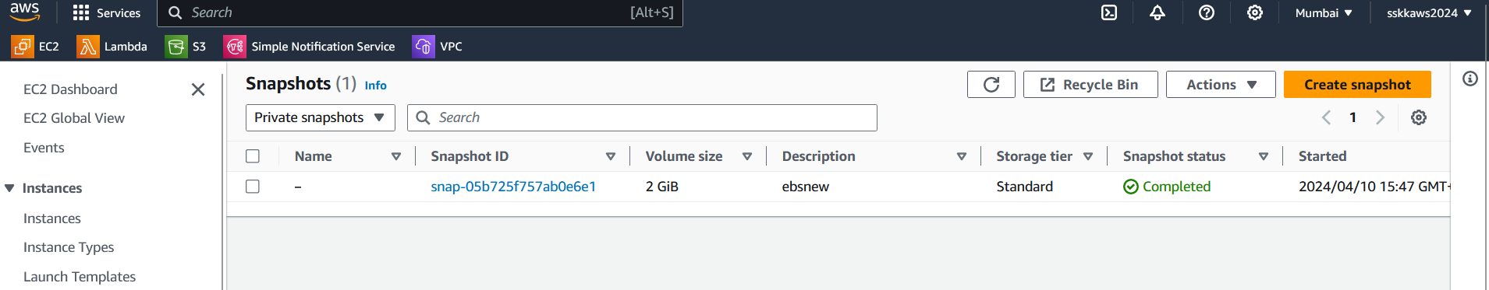

* + Create volume from the private snapshot shared from the other account

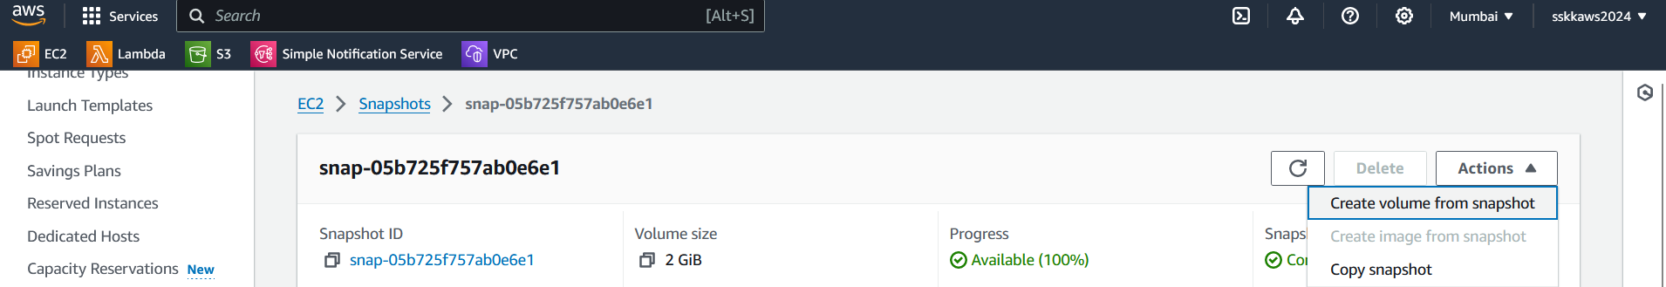

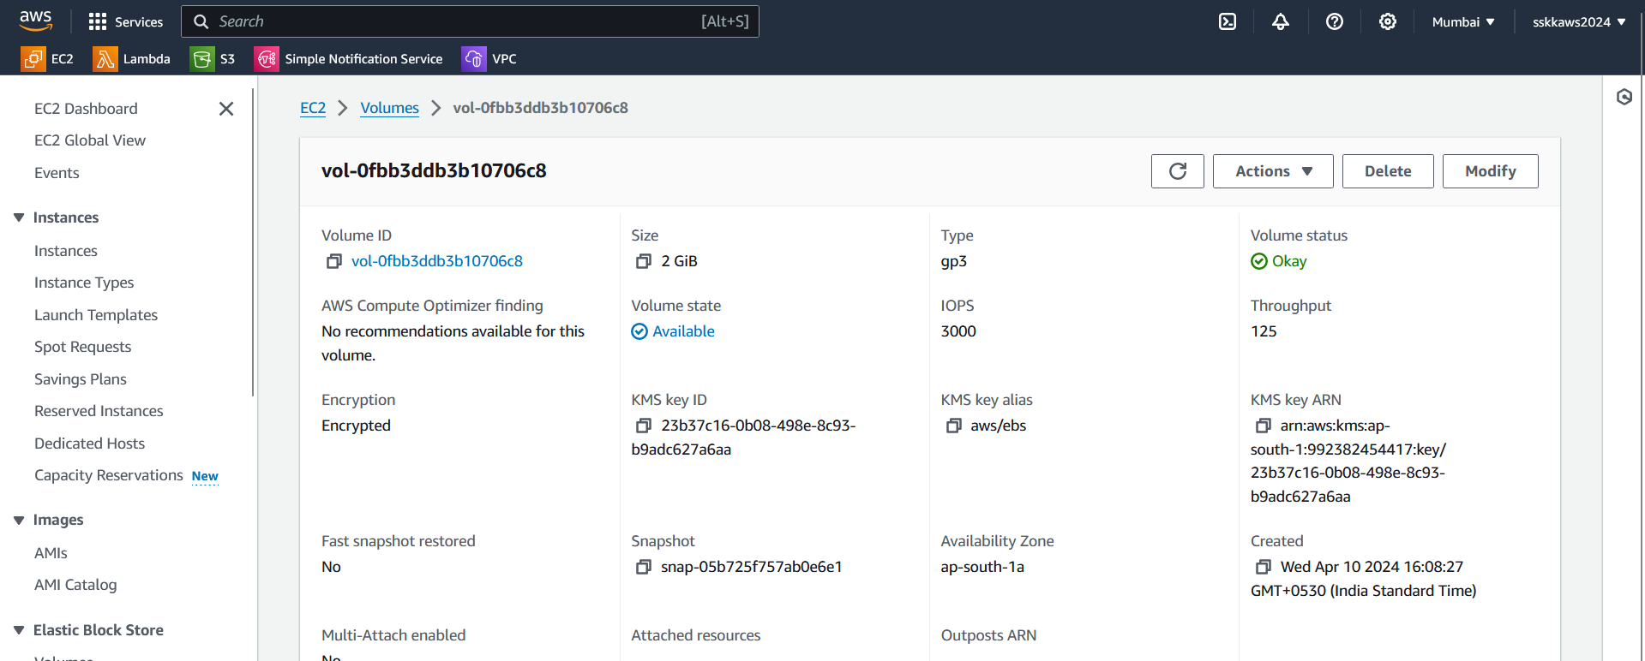

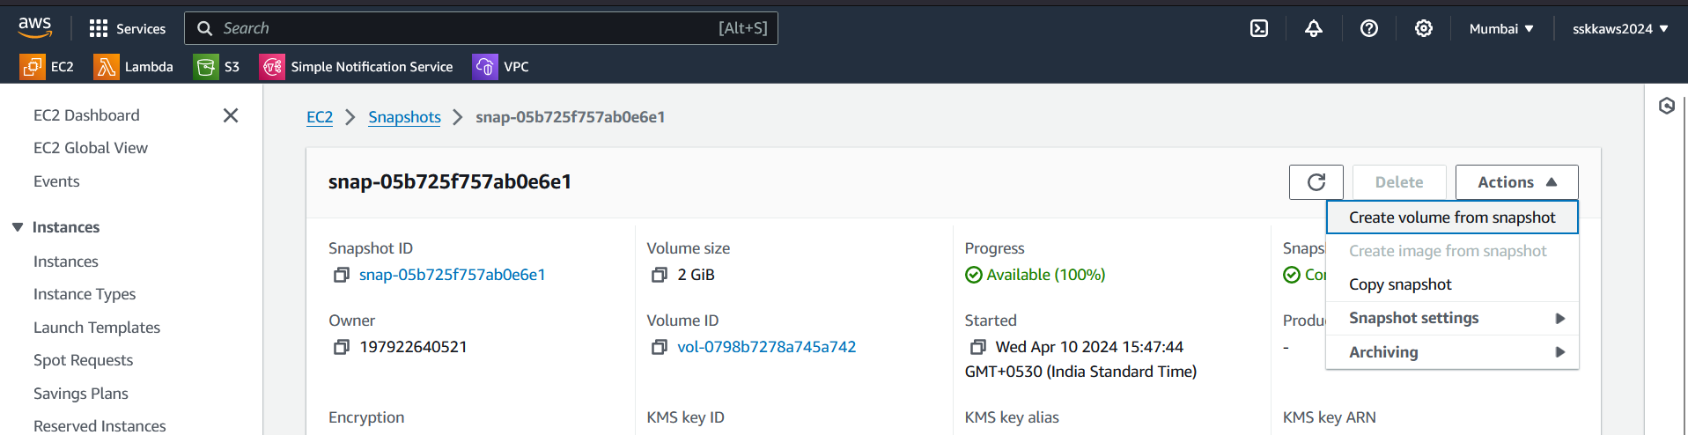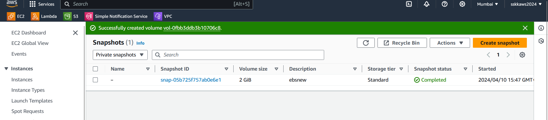

1. **Copy the Snapshot to Another Region (Cross-Region Access)**:
   * After sharing the snapshot with another account, you can copy it to another region:
     + In the "Snapshots" section of the Amazon EC2 console, select the shared snapshot.
     + Choose "Actions" -> "Copy snapshot".

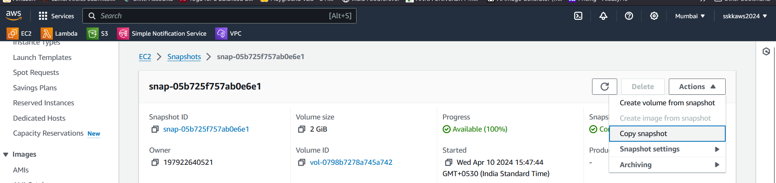

* + - Specify the destination region (e.g., ap-south-east-1 Singapore).

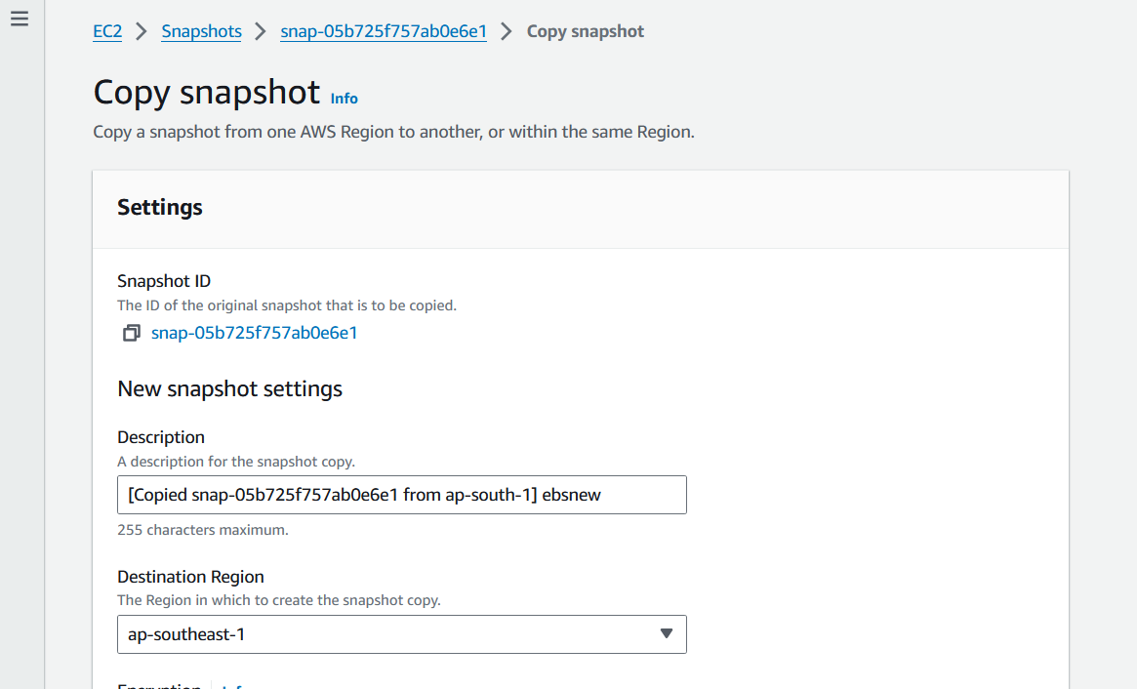

* + - Optionally, you can encrypt the snapshot during the copy process.

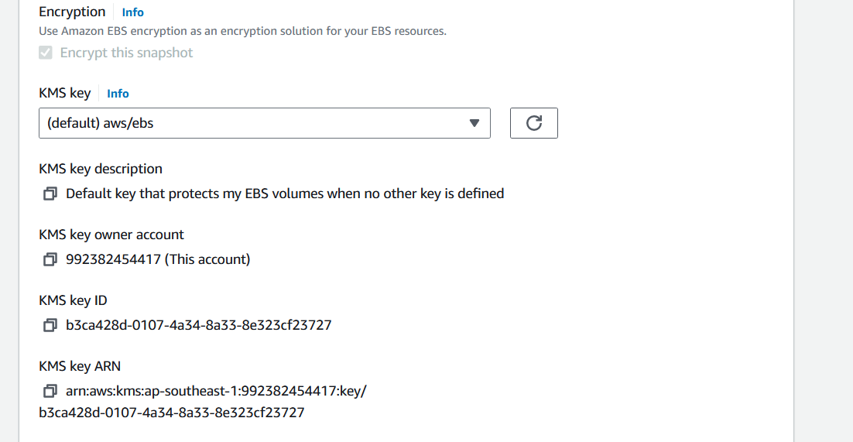

* + - Click "Copy snapshot".

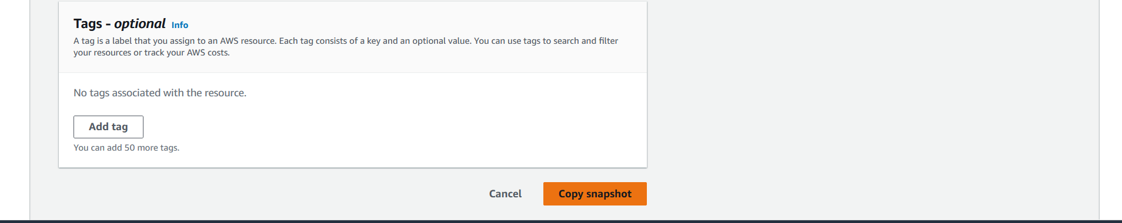

1. **Create a Volume from the Copied Snapshot in the Other Region**:
   * After the snapshot is copied to the other region, navigate to that region's EC2 console.
   * In the "Snapshots" section, locate the copied snapshot.

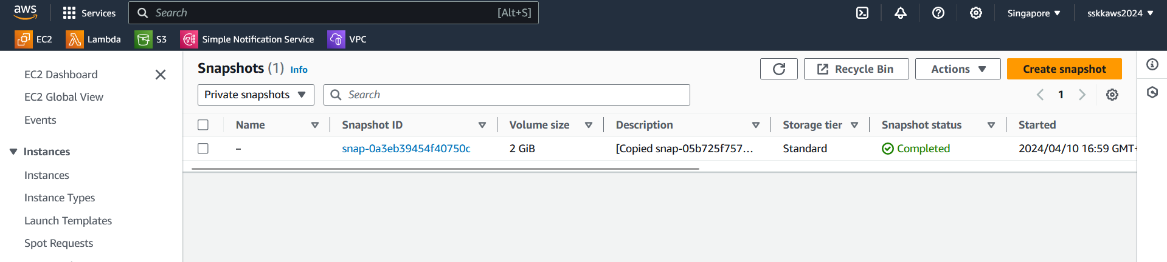

* + Create volume from the copied snapshot

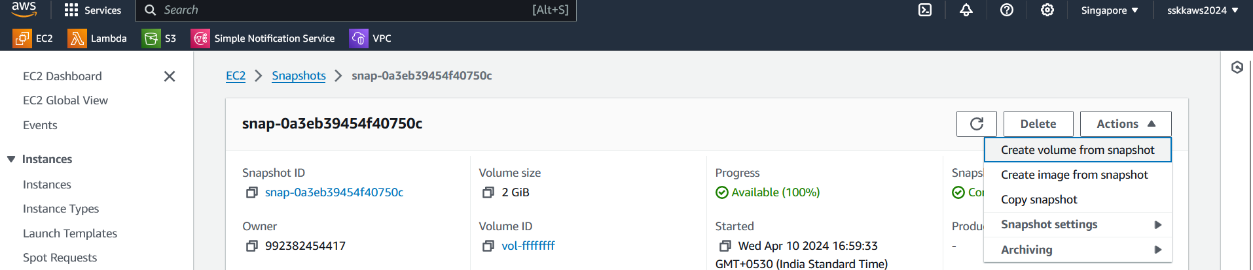

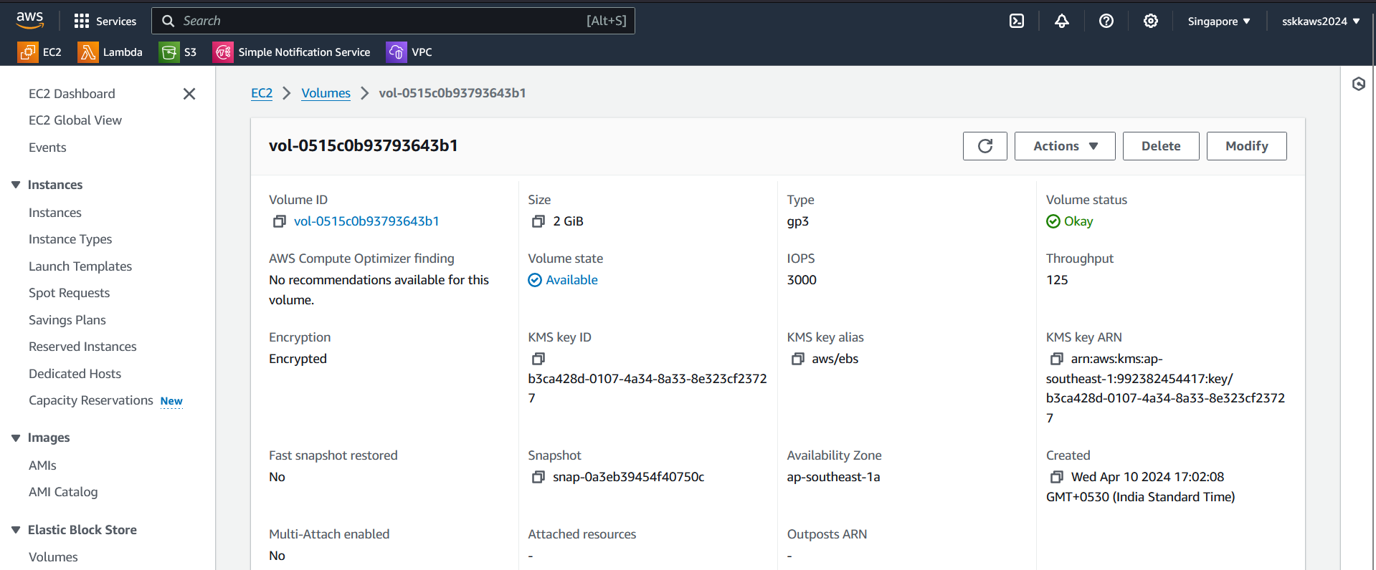

To perform cross-region actions like copying EBS snapshots from one region to another, you need to ensure that the IAM role associated with your Lambda function has permissions to perform the necessary actions in both the source and destination regions.

Here's how you can set up the IAM role for cross-region actions:

1. **Define Permissions for Cross-Region Actions:** In the IAM role's policy, include permissions for copying snapshots (ec2:CopySnapshot) in both the source and destination regions.

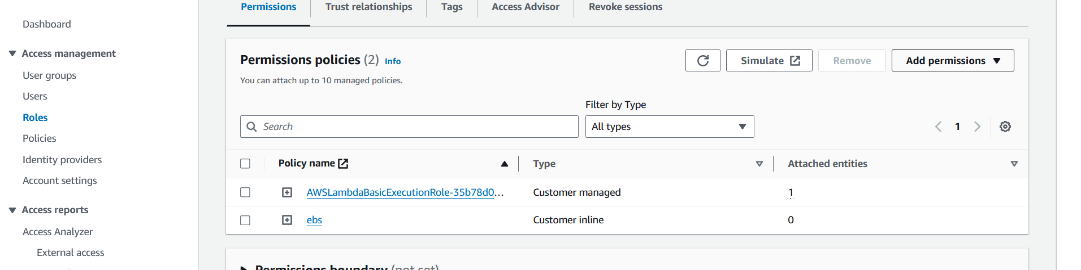

Here's an example IAM policy statement that grants permissions for copying snapshots across regions:

|  |
| --- |
| json  {  "Version": "2012-10-17",  "Statement": [  {  "Effect": "Allow",  "Action": "ec2:CopySnapshot",  "Resource": "*",  "Condition": {  "StringEquals": {  "ec2:Region": [  "source-region",  "destination-region"  ]  }  }  }  ]  } |

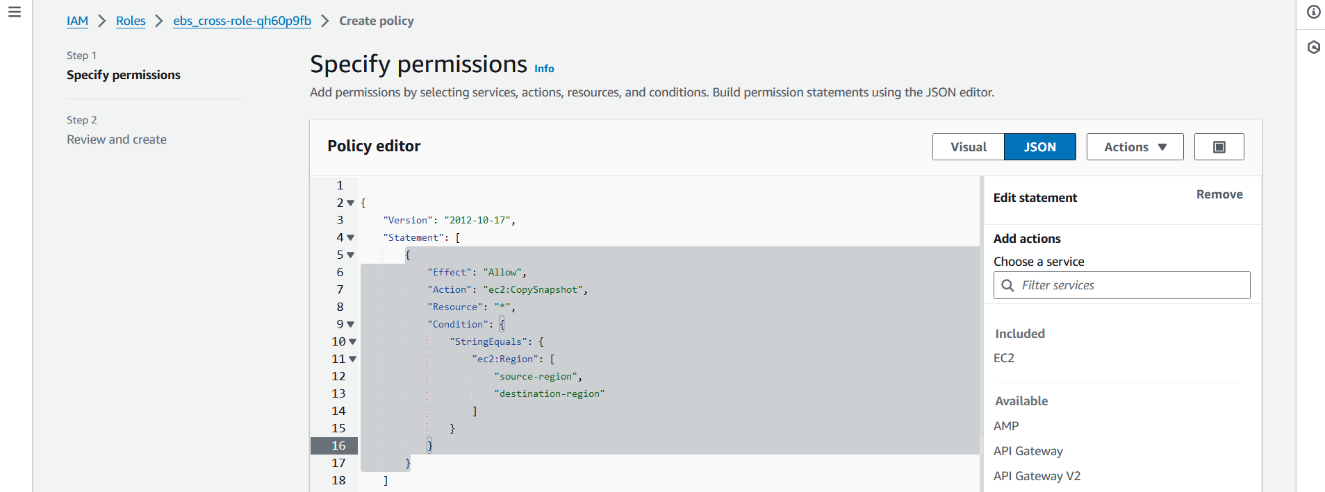

1. **Attach the IAM Role to Your Lambda Function:** Once you've defined the IAM role with the appropriate permissions, attach it to your Lambda function. You can do this in the AWS Lambda console by editing the function's configuration and selecting the IAM role you've created.

By following these steps, you'll ensure that your Lambda function has the necessary permissions to perform cross-region actions such as copying EBS snapshots from one region to another. Make sure to review and adjust the permissions based on your specific requirements and security policies.

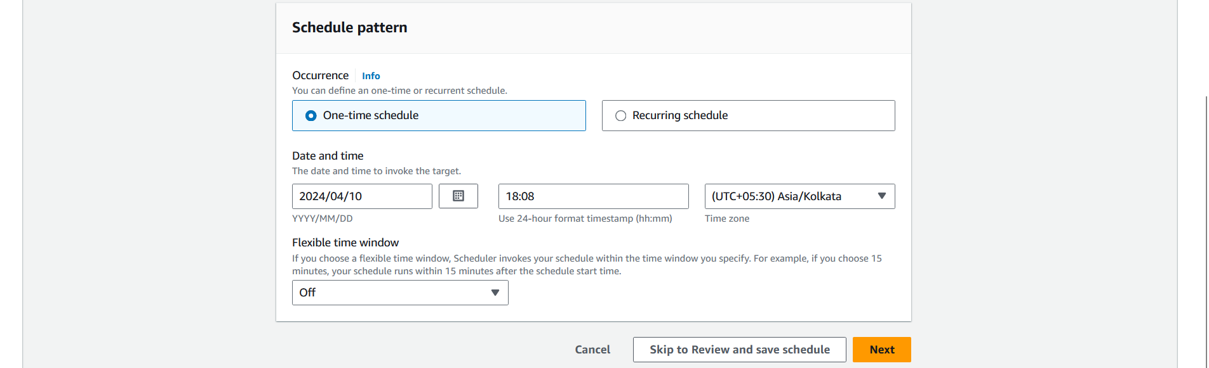

Below is an example CloudFormation template that creates a stack with an AWS::EC2::CopySnapshot resource to copy a snapshot to another region:

|  |
| --- |
| import boto3  def replicate_snapshot(event, context):  source_region = 'ap-south-1'  destination_region = 'ap-southeast-1'  snapshot_id = 'snap-0a3eb39454f40750c'  # Create clients for the source and destination regions  source_ec2_client = boto3.client('ec2', region_name=source_region)  destination_ec2_client = boto3.client('ec2', region_name=destination_region)  # Copy the snapshot to the destination region  response = destination_ec2_client.copy_snapshot(  SourceSnapshotId=snapshot_id,  SourceRegion=source_region,  Description=f"Replicated snapshot {snapshot_id} from {source_region} to {destination_region}"  )  # Retrieve the new snapshot ID created in the destination region  destination_snapshot_id = response['SnapshotId']  print(f"Snapshot {snapshot_id} replicated to {destination_region} with ID: {destination_snapshot_id}") |

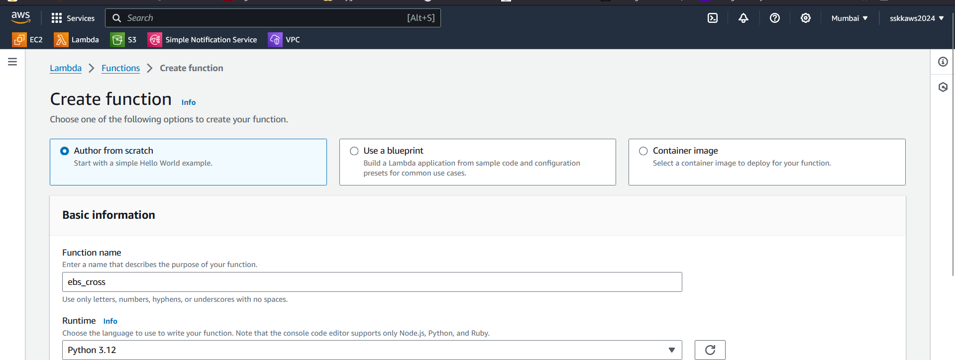

\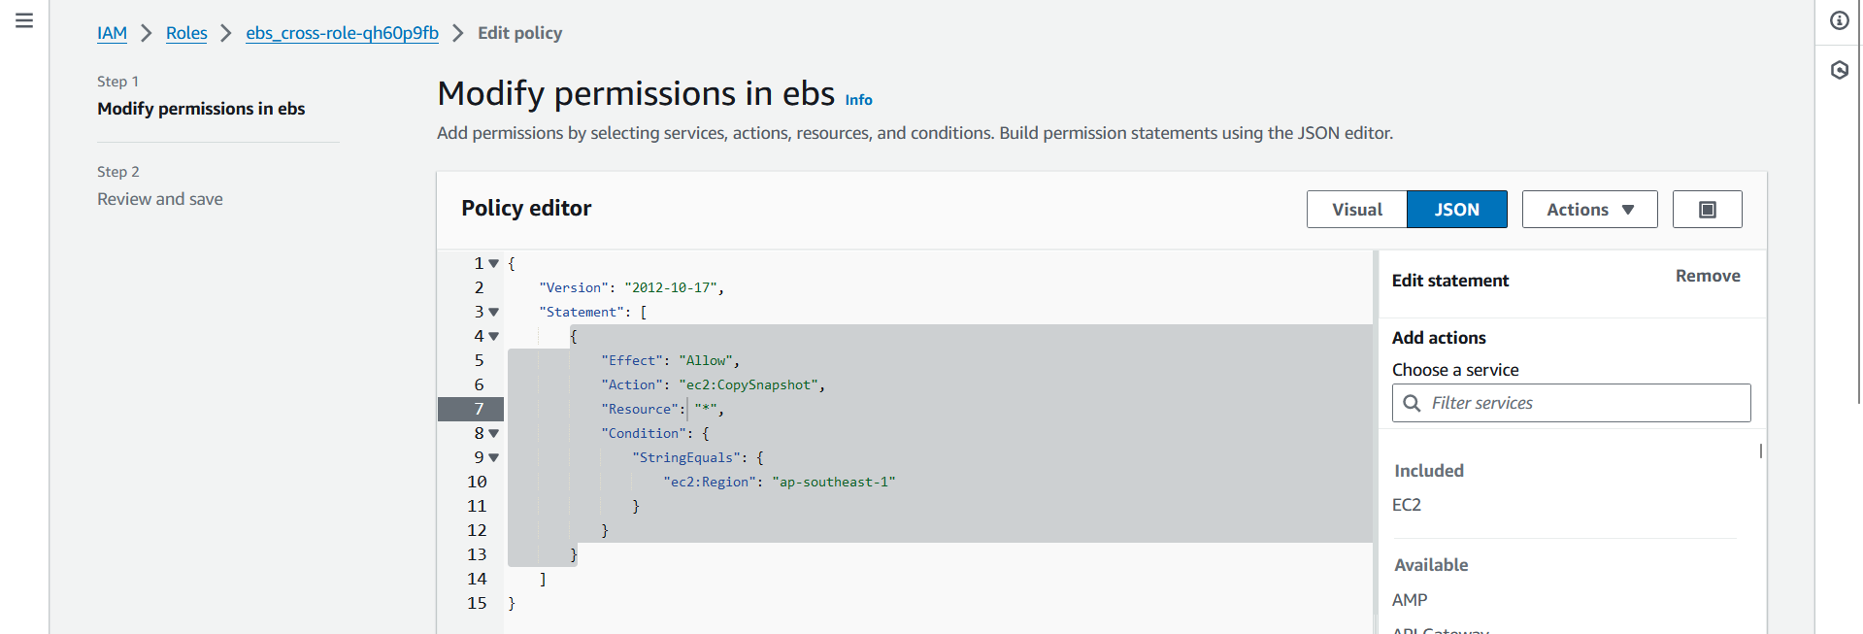

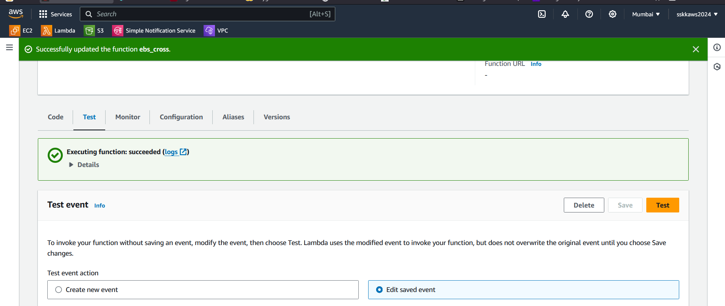

Once the CloudWatch Events rule is created, you can manually trigger the Lambda function by initiating the corresponding event. This can be done using the AWS Management Console, AWS CLI, AWS SDKs, or any tool that can generate AWS API requests.

